Experiment – 1

Aim:-
To demonstrate JavaScript integration methods (internal, inline, and external) in a web page and use console functions to display the user's environment information and a welcome message. Also, to understand the concepts of Internal CSS, Inline CSS, and External CSS for styling web pages.

Software/Tools Required:-
- Visual Studio Code (or any text editor)
- Web Browser (Google Chrome/Microsoft Edge)
- HTML, CSS, and JavaScript

Code:-

1.Internal html:-

<!DOCTYPE html>
<html>
<head>
<title>Internal JavaScript</title>

<style>
body{
margin:0;
height:100vh;
display:flex;
justify-content:center;
align-items:center;
background:linear-gradient(135deg,#4facfe,#00f2fe);
font-family:Arial,sans-serif;
}

.box{
text-align:center;
background:white;
padding:30px;
border-radius:15px;
box-shadow:0 0 15px rgba(0,0,0,0.3);
}

h1{color:#0d47a1;}
h2{color:#e91e63;}

p{
color:#2e7d32;
font-size:20px;
font-weight:bold;
}

button{
margin-top:20px;
padding:12px 25px;
border:none;
border-radius:8px;
background:#1565c0;
color:white;
font-size:18px;
cursor:pointer;
}

button:hover{
background:#0d47a1;
}
</style>
</head>

<body>

<div class="box">
<h1>Internal JavaScript Example</h1>
<h2>Student Details</h2>

<p>Name : Parth Jirapure</p>
<p>PRN : 24070521243</p>
<p>Semester : 5th</p>
<p>Section : D</p>

<button onclick="showMessage()">Click Here</button>
</div>

<script>
function showMessage() {
console.log("Server Environment : Development");
console.log("Welcome Parth Jirapure!");
}
</script>

</body>
</html>

2.inline html:-
<!DOCTYPE html>
<html>
<head>
<title>Inline JavaScript</title>

<style>
body{
margin:0;
height:100vh;
display:flex;
justify-content:center;
align-items:center;
background:linear-gradient(135deg,#43cea2,#185a9d);
font-family:Arial,sans-serif;
}
.box{
text-align:center;
background:white;
padding:30px;
border-radius:15px;
box-shadow:0 0 15px rgba(0,0,0,0.3);
}
h1{color:#1565c0;}
h2{color:#c2185b;}
p{
color:#2e7d32;
font-size:20px;
font-weight:bold;
}
button{
margin-top:20px;
padding:12px 25px;
border:none;
border-radius:8px;
background:#ff5722;
color:white;
font-size:18px;
cursor:pointer;
}
button:hover{
background:#e64a19;
}
</style>
</head>

<body>

<div class="box">
<h1>Inline JavaScript Example</h1>
<h2>Student Details</h2>
<p>Name : Parth Jirapure</p>
<p>PRN : 24070521243</p>
<p>Semester : 5th</p>
<p>Section : D</p>

<button onclick="console.log('Server Environment : Development'); console.log('Welcome Parth Jirapure!');">
Click Here
</button>
</div>

</body>
</html>

3.External html:-
<!DOCTYPE html>
<html>
<head>
<title>External JavaScript & CSS</title>

<link rel="stylesheet" href="style.css">
<script src="script.js"></script>
</head>

<body>

<div class="container">
<h1>External JavaScript Example</h1>
<h2>Student Details</h2>

<p><b>Name :</b> Parth Jirapure</p>
<p><b>PRN :</b> 24070521243</p>
<p><b>Semester :</b> 5th</p>
<p><b>Section :</b> D</p>

<button onclick="showMessage()">Click Here</button>
</div>

</body>
</html>
Style.css:-
body{
margin:0;
padding:0;
height:100vh;
display:flex;
justify-content:center;
align-items:center;
font-family:Arial, sans-serif;
background:linear-gradient(135deg, #a8edea, #fed6e3);
}

.container{
width:400px;
background:#ffffff;
padding:30px;
border-radius:10px;
text-align:center;
}

h1{
color:#3f51b5;
margin-bottom:10px;
}

h2{
color:#e91e63;
margin-bottom:20px;
}

p{
color:#00796b;
font-size:18px;
margin:8px 0;
}

button{
margin-top:20px;
padding:10px 20px;
font-size:16px;
background:#5c6bc0;
color:white;
border:none;
border-radius:5px;
cursor:pointer;
}

Theory:-
JavaScript is a client-side scripting language used to make web pages interactive and dynamic. It can be integrated into an HTML document in three ways:

Internal JavaScript: The JavaScript code is written inside the <script> tag within the HTML file. It is suitable for small projects or page-specific scripts.
Inline JavaScript: The JavaScript code is written directly inside HTML elements using event attributes such as onclick, onmouseover, etc. It is useful for simple actions but is not recommended for large applications.
External JavaScript: The JavaScript code is stored in a separate .js file and linked to the HTML document using the <script src="..."></script> tag. This improves code reusability, readability, and maintenance.
Similarly, CSS (Cascading Style Sheets) is used to style web pages and can be applied in three ways:
Inline CSS: Styles are applied directly to an HTML element using the style attribute.
Internal CSS: Styles are written inside the <style> tag within the HTML document and apply to that page only.
External CSS: Styles are written in a separate .css file and linked to the HTML document using the <link> tag. This is the most efficient and widely used method for styling multiple web pages.

Output:-

Internal Javascript:-

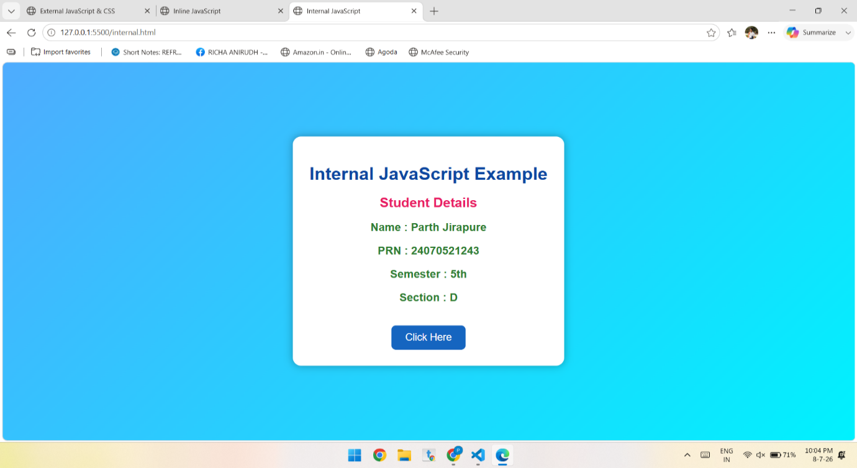

Inline Javascript:-

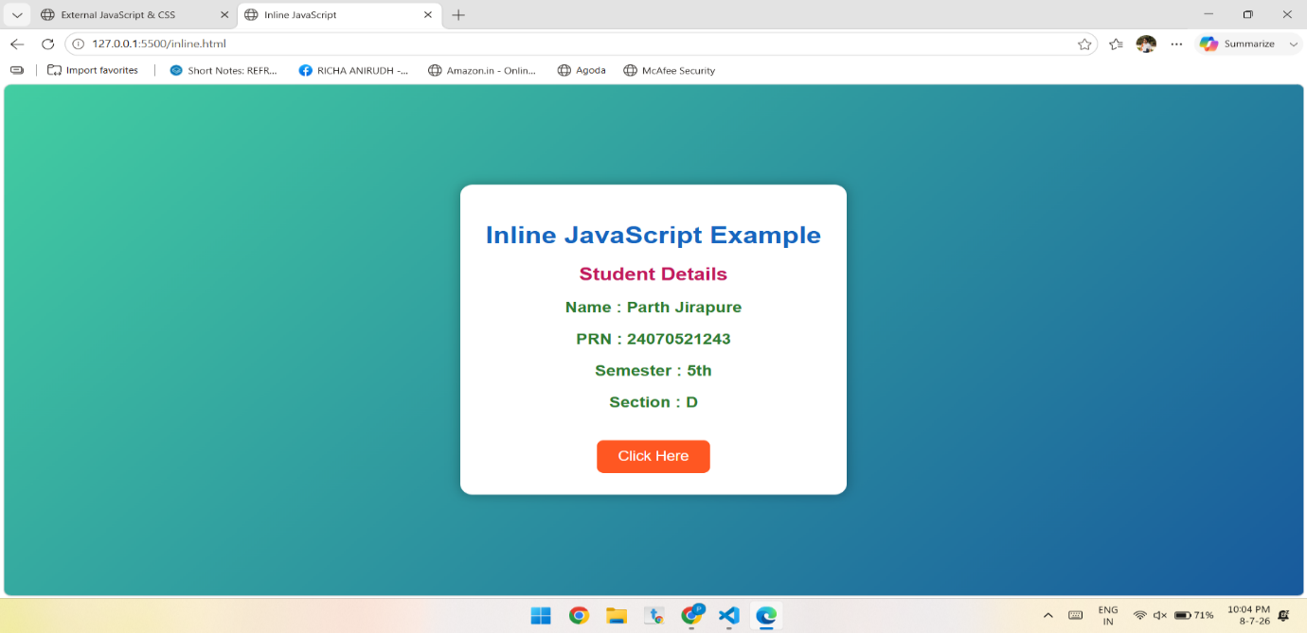
External Javascript:-

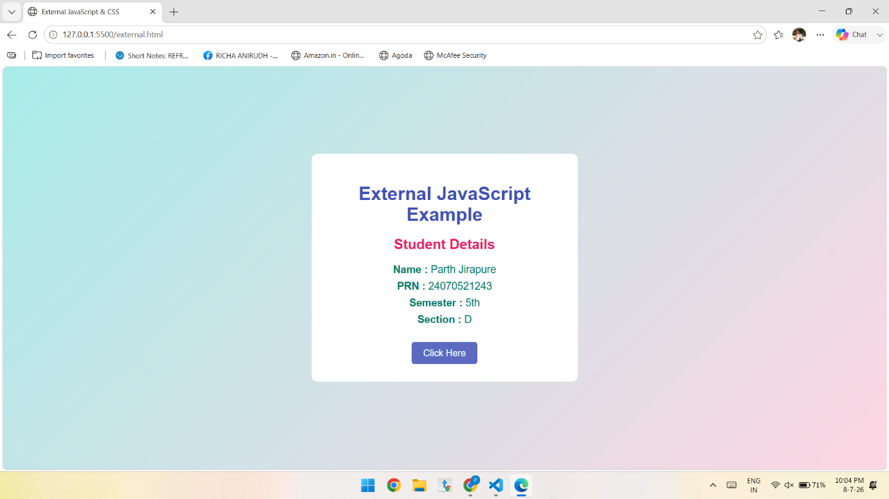

Conclusion:-
The experiment demonstrated the three methods of integrating JavaScript—internal, inline, and external—and showed how console functions can display a welcome message and user environment details for debugging and development purposes. It also explained the three CSS integration methods—inline, internal, and external—which provide different ways to style web pages. Understanding these techniques helps in creating well-structured, interactive, maintainable, and visually appealing web applications.

Case Study – 1
Aim:-
Create a webpage for the college department and link the student information page with it and write a Java Script Program to Display “ Welcome to SIT Nagpur ” in an alert Box

Software/Tools Required:-
- Visual Studio Code (or any text editor)
- Web Browser (Google Chrome/Microsoft Edge)
- HTML, CSS, and JavaScript

Code:-
<!DOCTYPE html>
<html>
<head>
<title>Student Information</title>
</head>
<body>

<h1>Student Information</h1>

<table border="1">
<tr>
<th>Roll No</th>
<th>Name</th>
<th>Branch</th>
</tr>
<tr>
<td>101</td>
<td>Rahul Sharma</td>
<td>Computer Science</td>
</tr>
<tr>
<td>102</td>
<td>Priya Verma</td>
<td>Computer Science</td>
</tr>
</table>

<br>
<a href="index.html">Back to Department Page</a>

</body>
</html>

Style.css:-

/* General Page Style */
body {
font-family: Arial, sans-serif;
background-color: #f2f2f2;
margin: 0;
padding: 20px;
}

/* Container */
.container {
width: 70%;
margin: auto;
background-color: white;
padding: 20px;
border-radius: 8px;
box-shadow: 0 0 10px rgba(0,0,0,0.2);
}

/* Heading */
h1 {
text-align: center;
color: #333;
}

/* Table */
table {
width: 100%;
border-collapse: collapse;
margin-top: 20px;
}

/* Table Cells */
table, th, td {
border: 1px solid #000;
}

th {
background-color: #007BFF;
color: white;
padding: 10px;
}

td {
padding: 10px;
text-align: center;
}

tr:nth-child(even) {
background-color: #f9f9f9;
}

tr:hover {
background-color: #e6f2ff;
}

/* Button Style */
.btn {
display: inline-block;
padding: 10px 15px;
background-color: #007BFF;
color: white;
text-decoration: none;
border-radius: 5px;
}

.btn:hover {
background-color: #0056b3;
}

Theory

HTML (HyperText Markup Language) is used to create and structure webpages. A college department webpage can contain headings, paragraphs, images, navigation links, and other information. The <a> (anchor) tag is used to create a hyperlink from one webpage to another. By specifying the href attribute, we can link the student information page with the department webpage.
JavaScript is a scripting language used to make webpages interactive and dynamic. The alert() function in JavaScript displays a message in a pop-up alert box. In this experiment, JavaScript is used to display the message “Welcome to SIT Nagpur” when the webpage is opened.

Output:-
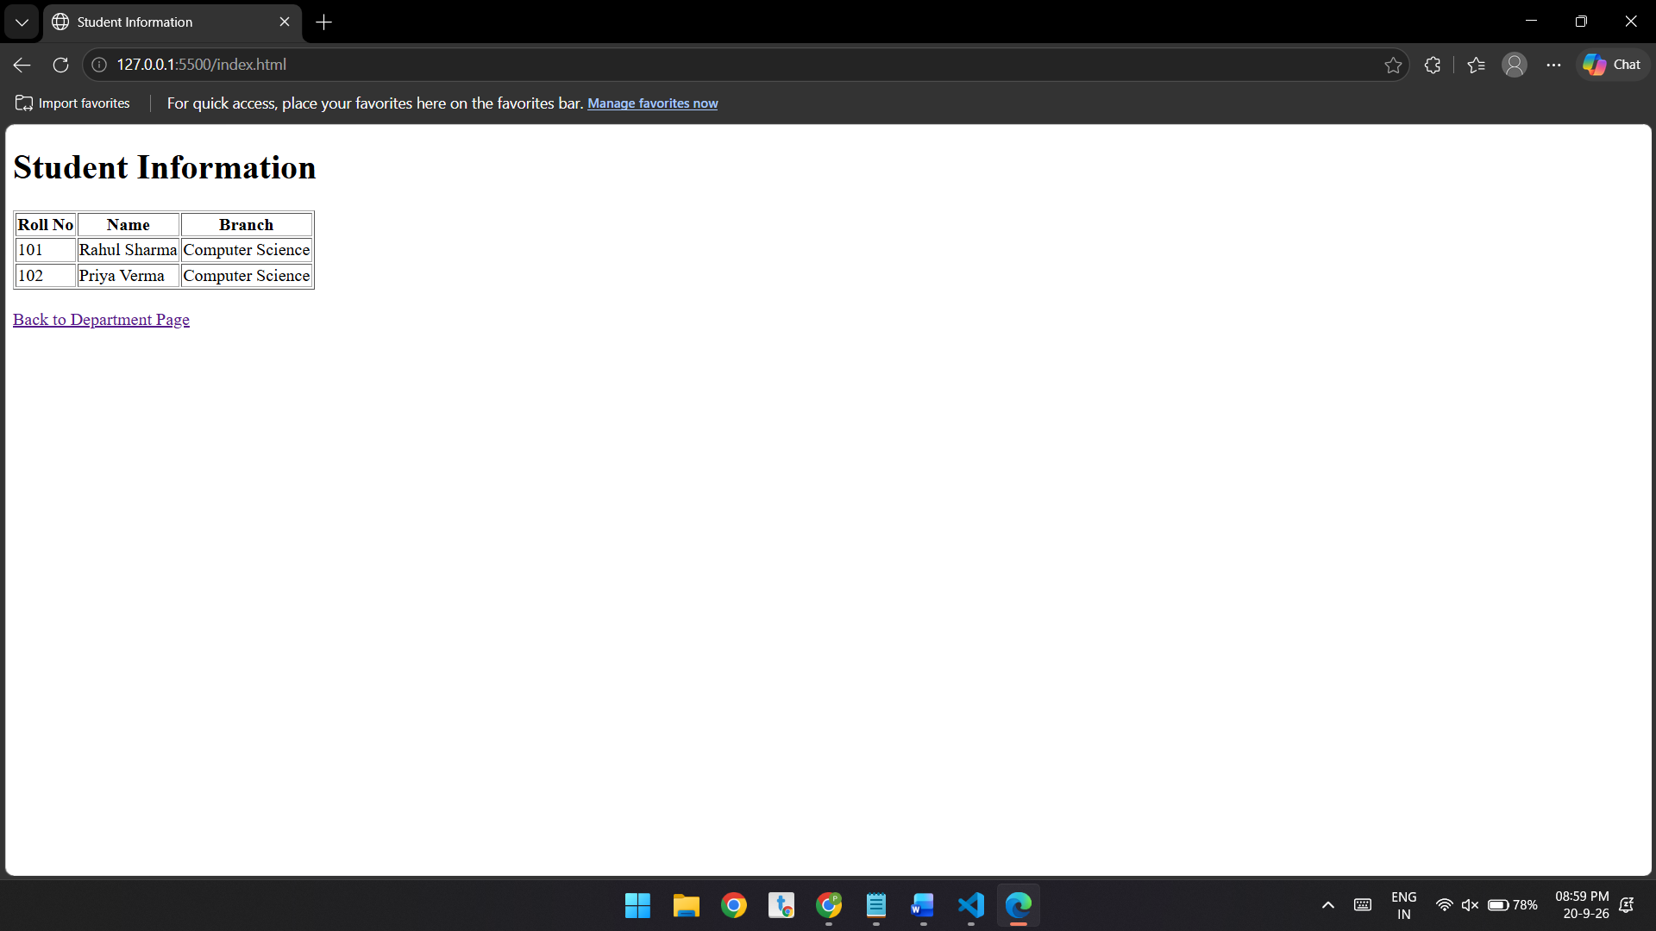

Conclusion
Thus, a college department webpage was successfully created using HTML, and a student information page was linked to it using the anchor tag. JavaScript was also successfully implemented to display “Welcome to SIT Nagpur” in an alert box. This experiment demonstrates the basic use of HTML hyperlinks and JavaScript for adding interactivity to webpages.

Experiment – 2

Aim:-
To demonstrate JavaScript integration methods (internal, inline, and external) in a web page and use console functions to display the user's environment information and a welcome message. Also, to understand the concepts of Internal CSS, Inline CSS, and External CSS for styling web pages.

Software/Tools Required:-
- Visual Studio Code (or any text editor)
- Web Browser (Google Chrome/Microsoft Edge)
- HTML, CSS, and JavaScript

Code:-
<!DOCTYPE html>
<html>
<head>
<title>Bill Generator</title>
</head>
<body>

<div id="output"></div>

<script>
function calculateBill() {

let name = prompt("Enter Customer Name:");
let mobile = prompt("Enter Mobile Number:");
let invoice = prompt("Enter Invoice Number:");
let product = prompt("Enter Product Name:");
let qty = parseFloat(prompt("Enter Quantity (Kg):"));
let rate = parseFloat(prompt("Enter Rate per Kg:"));
let discount = parseFloat(prompt("Enter Discount (%):"));
let gst = parseFloat(prompt("Enter GST (%):"));
let packing = parseFloat(prompt("Enter Packing Charges:"));
let payment = prompt("Enter Payment Mode (Cash/Card/UPI):");
let member = prompt("Membership? (Yes/No):");

let amount = qty * rate;
let discountAmount = amount * discount / 100;
let subtotal = amount - discountAmount;
let gstAmount = subtotal * gst / 100;
let total = subtotal + gstAmount + packing;

if (member && member.toLowerCase() === "yes") {
total -= total * 0.05;
}

document.getElementById("output").innerHTML = `
<h2>Invoice</h2>
<p><b>Customer Name:</b> ${name}</p>
<p><b>Mobile Number:</b> ${mobile}</p>
<p><b>Invoice Number:</b> ${invoice}</p>
<p><b>Product Name:</b> ${product}</p>
<p><b>Quantity:</b> ${qty} Kg</p>
<p><b>Rate:</b> ₹${rate.toFixed(2)}</p>
<p><b>Amount:</b> ₹${amount.toFixed(2)}</p>
<p><b>Discount:</b> ₹${discountAmount.toFixed(2)}</p>
<p><b>GST:</b> ₹${gstAmount.toFixed(2)}</p>
<p><b>Packing Charges:</b> ₹${packing.toFixed(2)}</p>
<h3>Total Bill: ₹${total.toFixed(2)}</h3>
<p><b>Payment Mode:</b> ${payment}</p>
<p><b>Membership:</b> ${member}</p>
`;
}

window.onload = calculateBill;
</script>

</body>
</html>

Theory:-
This program demonstrates the use of JavaScript variables (var, let, and const), template literals, and object destructuring. The user enters customer details, product name, quantity, and price per item using prompt(). The program calculates the total amount, GST (18%), and the final bill. The result is displayed dynamically on the web page using document.write().

Output:-
Bill:-

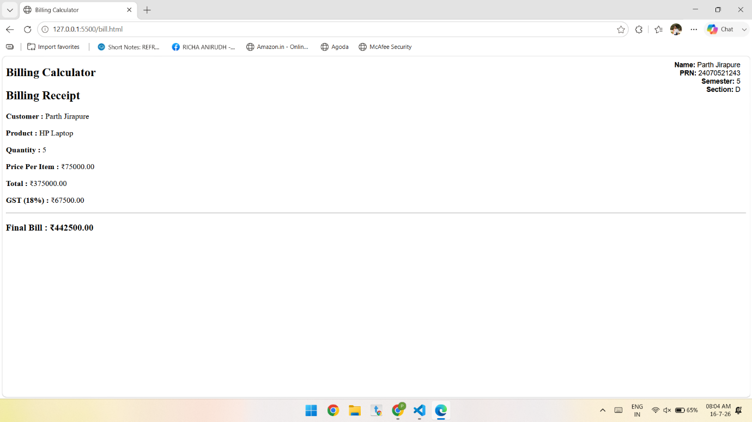

Conclusion:-
The Billing Calculator was successfully implemented using JavaScript. It accepts user input, performs bill and GST calculations, and displays the final bill. The program demonstrates the use of var, let, const, template literals, and object destructuring effectively.

Case Study – 2
Aim:-
Develop the webpage for an online shopping website with using HTML CSS and HTML5 tags and calculate the bill.

Software/Tools Required:-
- Visual Studio Code (or any text editor)
- Web Browser (Google Chrome/Microsoft Edge)
- HTML, CSS, and JavaScript

Code:-
<!DOCTYPE html>
<html>
<head>
<title>Bill Generator</title>
</head>
<body>

<div id="output"></div>

<script>
function calculateBill() {

let name = prompt("Enter Customer Name:");
let mobile = prompt("Enter Mobile Number:");
let invoice = prompt("Enter Invoice Number:");
let product = prompt("Enter Product Name:");
let qty = parseFloat(prompt("Enter Quantity (Kg):"));
let rate = parseFloat(prompt("Enter Rate per Kg:"));
let discount = parseFloat(prompt("Enter Discount (%):"));
let gst = parseFloat(prompt("Enter GST (%):"));
let packing = parseFloat(prompt("Enter Packing Charges:"));
let payment = prompt("Enter Payment Mode (Cash/Card/UPI):");
let member = prompt("Membership? (Yes/No):");

let amount = qty * rate;
let discountAmount = amount * discount / 100;
let subtotal = amount - discountAmount;
let gstAmount = subtotal * gst / 100;
let total = subtotal + gstAmount + packing;

if (member && member.toLowerCase() === "yes") {
total -= total * 0.05;
}

document.getElementById("output").innerHTML = `
<h2>Invoice</h2>
<p><b>Customer Name:</b> ${name}</p>
<p><b>Mobile Number:</b> ${mobile}</p>
<p><b>Invoice Number:</b> ${invoice}</p>
<p><b>Product Name:</b> ${product}</p>
<p><b>Quantity:</b> ${qty} Kg</p>
<p><b>Rate:</b> ₹${rate.toFixed(2)}</p>
<p><b>Amount:</b> ₹${amount.toFixed(2)}</p>
<p><b>Discount:</b> ₹${discountAmount.toFixed(2)}</p>
<p><b>GST:</b> ₹${gstAmount.toFixed(2)}</p>
<p><b>Packing Charges:</b> ₹${packing.toFixed(2)}</p>
<h3>Total Bill: ₹${total.toFixed(2)}</h3>
<p><b>Payment Mode:</b> ${payment}</p>
<p><b>Membership:</b> ${member}</p>
`;
}

window.onload = calculateBill;
</script>

</body>
</html>

Theory:-
The Online Shopping Bill Generator is a web-based application developed using HTML, CSS, and JavaScript. The main purpose of this application is to generate a customer bill by accepting details such as customer name, mobile number, invoice number, product name, quantity, rate, discount, GST, packing charges, payment mode, and membership status.
HTML is used to create the basic structure of the webpage and display the generated invoice. HTML5 tags such as <html>, <head>, <title>, <body>, <div>, <h2>, <h3>, and <p> are used to organize and present the content.
JavaScript is used to make the webpage interactive and perform the bill calculations. The prompt() function collects information from the user, while variables store the entered values. The bill is calculated using the following steps:
- Amount Calculation:
Amount = Quantity × Rate
- Discount Calculation:
Discount Amount = Amount × Discount (%) / 100
- Subtotal Calculation:
Subtotal = Amount − Discount Amount
- GST Calculation:
GST Amount = Subtotal × GST (%) / 100
- Total Bill Calculation:
Total = Subtotal + GST Amount + Packing Charges
- Membership Discount:
If the customer is a member, an additional 5% discount is applied to the calculated total.
The toFixed(2) method is used to display monetary values up to two decimal places. Finally, the innerHTML property displays the generated invoice dynamically inside the <div id="output"> element. Thus, the program demonstrates how HTML and JavaScript can be combined to create a simple shopping bill generation system. Humanity has somehow managed to make arithmetic require a webpage, but at least this one does the job.

Output:-
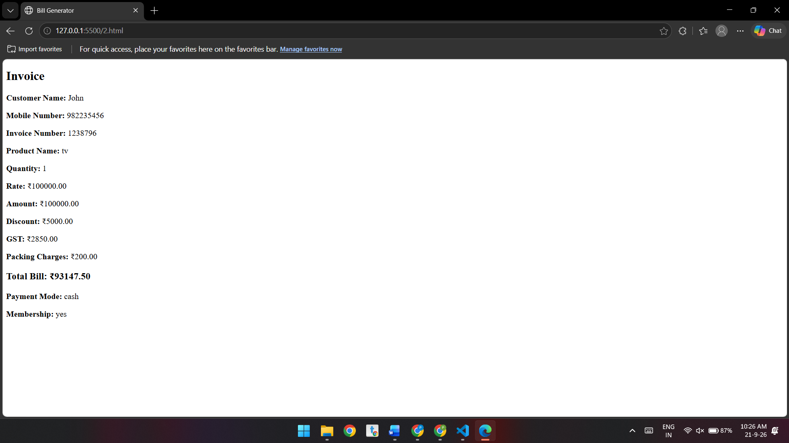

Conclusion:-
The Online Shopping Bill Generator successfully demonstrates the use of HTML, HTML5, and JavaScript for developing a simple online shopping application. It accepts customer and product details, calculates the amount, discount, GST, packing charges, and membership discount, and displays the final bill in a clear invoice format.
This project helps in understanding user input, variables, arithmetic operations, conditional statements, functions, DOM manipulation, and dynamic webpage generation using JavaScript. It can be further improved by adding CSS styling, multiple products, a shopping cart, input validation, print/download options, and a more user-friendly form-based interface.

Experiment – 3

Aim:-
Implement control structures and form validation; create a grading system based on user-entered marks
Software/Tools Required:-
- Visual Studio Code (or any text editor)
- Web Browser (Google Chrome/Microsoft Edge)
- HTML, CSS, and JavaScript

Code:-
<!DOCTYPE html>
<html>
<head>
<title>Student Grading System</title>
</head>

<body>

<!-- Student Details -->
<div style="position:absolute; top:10px; right:20px; text-align:right; font-family:Arial;">
<b>Name:</b> Parth Jirapure<br>
<b>PRN:</b> 24070521243<br>
<b>Semester:</b> 5<br>
<b>Section:</b> D
</div>

<h2>Student Grading System</h2>

<script>

// Student Name
let studentName = prompt("Enter Student Name:");

// PRN Validation
let prn = prompt("Enter 11 Digit PRN:");

while (!/^\d{11}$/.test(prn)) {
alert("Invalid PRN! Enter exactly 11 digits.");
prn = prompt("Enter 11 Digit PRN:");
}

// Number of Subjects Validation
let numSubjects = prompt("Enter Number of Subjects:");

while (!/^[1-9]\d*$/.test(numSubjects)) {
alert("Error! Enter a valid whole number.");
numSubjects = prompt("Re-enter Number of Subjects:");
}

numSubjects = Number(numSubjects);

let total = 0;
let subjects = [];

// Subject Details
for (let i = 1; i <= numSubjects; i++) {

let subject = prompt("Enter Subject " + i + " Name:");

let marks = prompt("Enter Marks for " + subject + ":");

// Marks Validation
while (!/^\d+$/.test(marks)) {
alert("Error! Marks should contain numbers only.");
marks = prompt("Re-enter Marks for " + subject + ":");
}

marks = Number(marks);

while (marks < 0 || marks > 100) {
alert("Marks should be between 0 and 100.");
marks = Number(prompt("Re-enter Marks for " + subject + ":"));
}

subjects.push({
name: subject,
marks: marks
});

total += marks;
}

// Percentage
let percentage = total / numSubjects;

// Grade Calculation
let grade;

if (percentage >= 90)
grade = "A+";
else if (percentage >= 80)
grade = "A";
else if (percentage >= 70)
grade = "B";
else if (percentage >= 60)
grade = "C";
else if (percentage >= 50)
grade = "D";
else
grade = "F";

// Output
document.write("<h2>Student Result</h2>");
document.write("<p><b>Student Name:</b> " + studentName + "</p>");
document.write("<p><b>PRN:</b> " + prn + "</p>");

document.write("<h3>Subjects</h3>");

for (let i = 0; i < subjects.length; i++) {
document.write("<p>" + subjects[i].name + " : " + subjects[i].marks + "</p>");
}

document.write("<hr>");
document.write("<p><b>Total Marks:</b> " + total + "</p>");
document.write("<p><b>Percentage:</b> " + percentage.toFixed(2) + "%</p>");
document.write("<h3>Grade: " + grade + "</h3>");

</script>

</body>
</html>

Theory:-
This program demonstrates the use of JavaScript control structures such as while loops, for loops, and if-else statements along with regular expressions for input validation. The user enters the student's name, PRN, number of subjects, subject names, and marks through prompt() dialogs. The program validates the PRN, subject count, and marks to ensure correct input. It then calculates the total marks, percentage, and assigns a grade based on the percentage obtained.

Output:-
Grade sheet :-
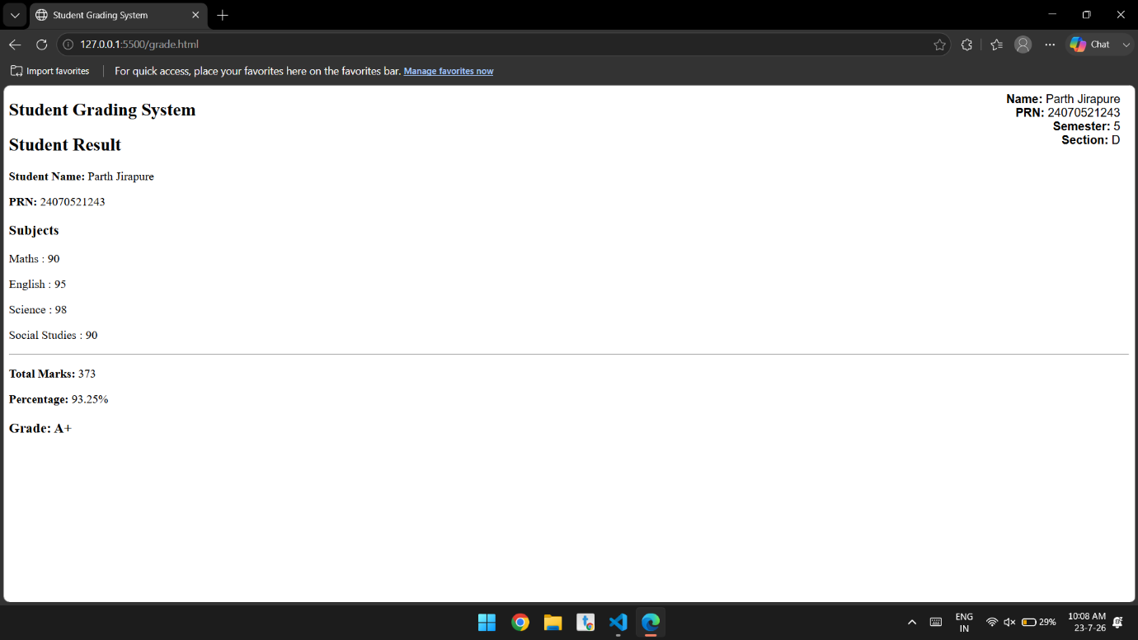

Conclusion:-
The Student Grading System was successfully implemented using JavaScript. It accepts and validates user input, calculates the total marks and percentage, and assigns grades using control structures. The program demonstrates the effective use of loops, conditional statements, regular expressions for form validation, arrays, and dynamic output generation using document.write(). It provides a simple and efficient way to automate student result calculation.

Case study – 3

Aim:-
Write a Javascript program that accepts students marks and displays the scholarship category.

Software/Tools Required:-
- Visual Studio Code (or any text editor)
- Web Browser (Google Chrome/Microsoft Edge)
- HTML, CSS, and JavaScript

Code:-
<!DOCTYPE html>
<html>
<head>
<title>Scholarship Eligibility System</title>
</head>

<body>

<!-- Student Details -->
<div style="position:absolute; top:10px; right:20px; text-align:right; font-family:Arial;">
<b>Name:</b> Parth Jirapure<br>
<b>PRN:</b> 24070521243<br>
<b>Semester:</b> 5<br>
<b>Section:</b> D
</div>

<h2>Scholarship Eligibility System</h2>

<script>

// Student Name
let studentName = prompt("Enter Student Name:");

// PRN Validation
let prn = prompt("Enter 11 Digit PRN:");

while (!/^\d{11}$/.test(prn)) {
alert("Invalid PRN! Enter exactly 11 digits.");
prn = prompt("Enter 11 Digit PRN:");
}

// Marks Validation
let marks = prompt("Enter Student Marks (0-100):");

while (!/^\d+$/.test(marks)) {
alert("Marks should contain numbers only.");
marks = prompt("Re-enter Student Marks:");
}

marks = Number(marks);

while (marks < 0 || marks > 100) {
alert("Marks should be between 0 and 100.");
marks = Number(prompt("Re-enter Student Marks:"));
}

// Scholarship Calculation
let scholarship;

if (marks < 50)
scholarship = "Not Eligible";
else if (marks >= 50 && marks <= 69)
scholarship = "Bronze Scholarship";
else if (marks >= 70 && marks <= 84)
scholarship = "Silver Scholarship";
else if (marks >= 85 && marks <= 94)
scholarship = "Gold Scholarship";
else
scholarship = "Platinum Scholarship";

// Output
document.write("<h2>Scholarship Result</h2>");
document.write("<p><b>Student Name:</b> " + studentName + "</p>");
document.write("<p><b>PRN:</b> " + prn + "</p>");
document.write("<p><b>Marks:</b> " + marks + "</p>");
document.write("<hr>");
document.write("<h3>Scholarship Category: " + scholarship + "</h3>");
</script>
</body>
</html>

Output:-
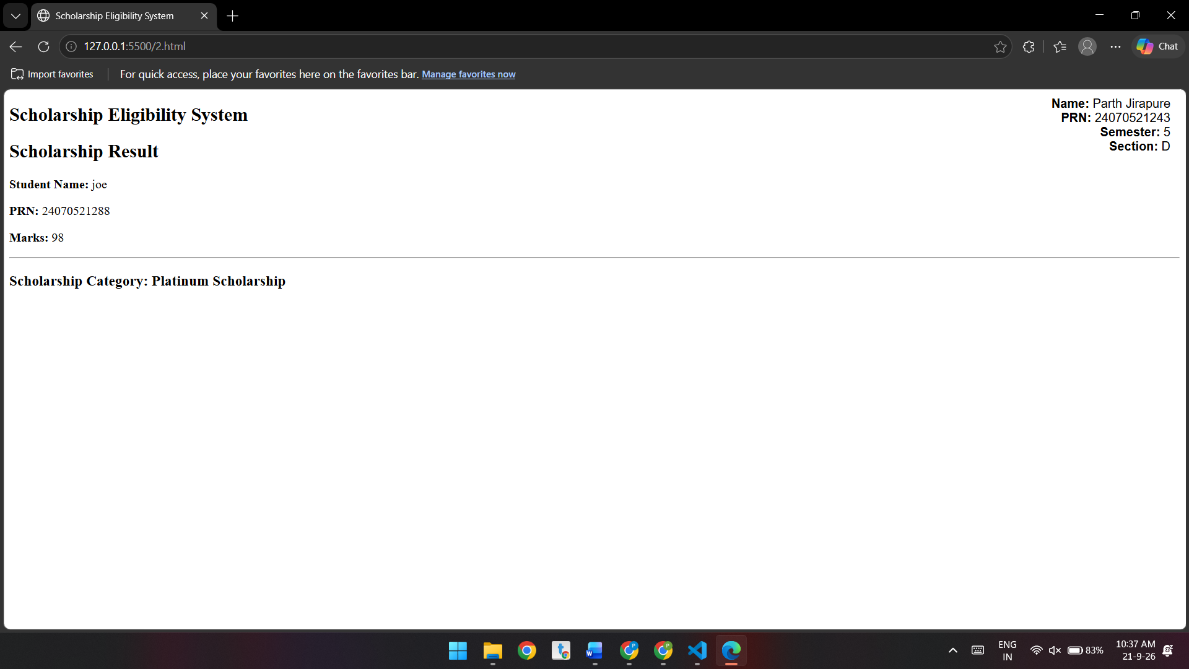
Theory:-
Theory
The Scholarship Eligibility System is a web-based application developed using HTML, CSS, and JavaScript to validate student details and determine scholarship eligibility based on marks.
- HTML creates the webpage structure and displays student and scholarship information.
- CSS is used to format and position the student details.
- JavaScript handles user input, validation, control structures, and scholarship calculation.
- The PRN is validated using a regular expression to ensure it contains exactly 11 digits.
- Marks are validated to ensure they are numeric and between 0 and 100.
- An if-else-if structure assigns the scholarship category:
  - Below 50: Not Eligible
  - 50–69: Bronze
  - 70–84: Silver
  - 85–94: Gold
  - 95–100: Platinum
- Finally, document.write() displays the student's details and scholarship result.

Conclusion:-
The Scholarship Eligibility System demonstrates control structures and form validation using HTML, CSS, and JavaScript.
It validates the student’s PRN and marks and prevents invalid inputs.
The system assigns a scholarship category based on the marks entered.
This project provides practical understanding of loops, conditions, validation, and JavaScript functions.

Experiment – 4

Aim:-
Use function types, scope, and closures; apply try-catch; build a palindrome checker.

Software/Tools Required:-
- Visual Studio Code (or any text editor)
- Web Browser (Google Chrome/Microsoft Edge)
- HTML, CSS, and JavaScript

Code:-
<!DOCTYPE html>
<html lang="en">
<head>
<meta charset="UTF-8">
<meta name="viewport" content="width=device-width, initial-scale=1.0">
<title>Advanced Palindrome Checker</title>

<style>
body{
font-family:Arial, sans-serif;
background:#f2f2f2;
}

.container{
width:420px;
margin:50px auto;
background:white;
padding:20px;
border-radius:10px;
box-shadow:0 0 10px gray;
}

input{
width:100%;
padding:10px;
margin:10px 0;
}

button{
width:100%;
padding:10px;
background:#2196F3;
color:white;
border:none;
cursor:pointer;
}

button:hover{
background:#1565c0;
}

#result,#count{
margin-top:15px;
font-weight:bold;
}
</style>

</head>
<body>

<div class="container">

<h2>Palindrome Checker</h2>

<input type="text" id="text" placeholder="Enter a word or sentence">

<button onclick="checkPalindrome()">
Check
</button>

<p id="result"></p>
<p id="count"></p>

</div>

<script>

/*=========================
GLOBAL SCOPE
==========================*/

let appName = "Palindrome Checker";
const version = "1.0";

console.log(appName, version);

/*=========================
IIFE FUNCTION
Runs automatically
==========================*/

(function(){
console.log("Application Started");
})();

/*=========================
FUNCTION DECLARATION
==========================*/

function cleanText(str){
return str.toLowerCase().replace(/[^a-z0-9]/g,"");
}

/*=========================
FUNCTION EXPRESSION
==========================*/

const reverseText = function(str){
return str.split("").reverse().join("");
};

/*=========================
ARROW FUNCTION
==========================*/

const isPalindrome = text =>
cleanText(text) === reverseText(cleanText(text));

/*=========================
ANONYMOUS FUNCTION
Stored in a variable
==========================*/

const welcome = function(){
console.log("Welcome User");
};

welcome();

/*=========================
CALLBACK FUNCTION
==========================*/

function displayMessage(message, callback){
document.getElementById("result").innerHTML = message;

callback();
}

/*=========================
CLOSURE
==========================*/

function createCounter(){

let count = 0;

return function(){

count++;

return count;

}

}

const counter = createCounter();

/*=========================
LEXICAL SCOPE
==========================*/

function outerFunction(){

let outerMessage = "Lexical Scope Example";

function innerFunction(){

console.log(outerMessage);

}

innerFunction();

}

outerFunction();

/*=========================
MAIN FUNCTION
==========================*/

function checkPalindrome(){

try{

let input = document.getElementById("text").value;

// Function Scope
let resultText = "";

if(input.trim()=="")
throw "Please enter some text.";

if(isPalindrome(input))
resultText = "<span style='color:green;'>It is a Palindrome ✔</span>";
else
resultText = "<span style='color:red;'>It is not a Palindrome ✖</span>";

// Callback Function
displayMessage(resultText,function(){

let total = counter();

document.getElementById("count").innerHTML =
"Total Checks: " + total;

});

// Block Scope
if(true){

let blockVariable = "Visible only inside this block";
console.log(blockVariable);

const blockConstant = "Block Constant";
console.log(blockConstant);

}

}

catch(error){

document.getElementById("result").innerHTML =
"<span style='color:red;'>" + error + "</span>";

}

finally{

console.log("Palindrome check completed.");

}

}

</script>
</body>
</html>

Theory:-
Functions are reusable blocks of code that perform specific tasks. They can be declared in different ways, such as named functions, anonymous functions, arrow functions, and immediately invoked function expressions (IIFEs). Function types improve code modularity, readability, and reusability.

Scope defines the accessibility of variables in a program. Variables may have global scope, function scope, or block scope. Proper use of scope prevents naming conflicts and protects data from unintended modification.

A closure is created when an inner function retains access to the variables of its outer function even after the outer function has finished execution. Closures are useful for data encapsulation, maintaining state, and implementing private variables.

Exception handling using try-catch allows a program to detect and handle runtime errors gracefully. The try block contains code that may generate an exception, while the catch block handles the error without terminating the program unexpectedly.

A palindrome checker determines whether a string or number reads the same forwards and backwards. The process generally involves removing unnecessary characters (such as spaces and punctuation), converting the text to a common case, reversing it, and comparing it with the original string. If both match, the input is identified as a palindrome.

Output:-
Palindrome Checker :-

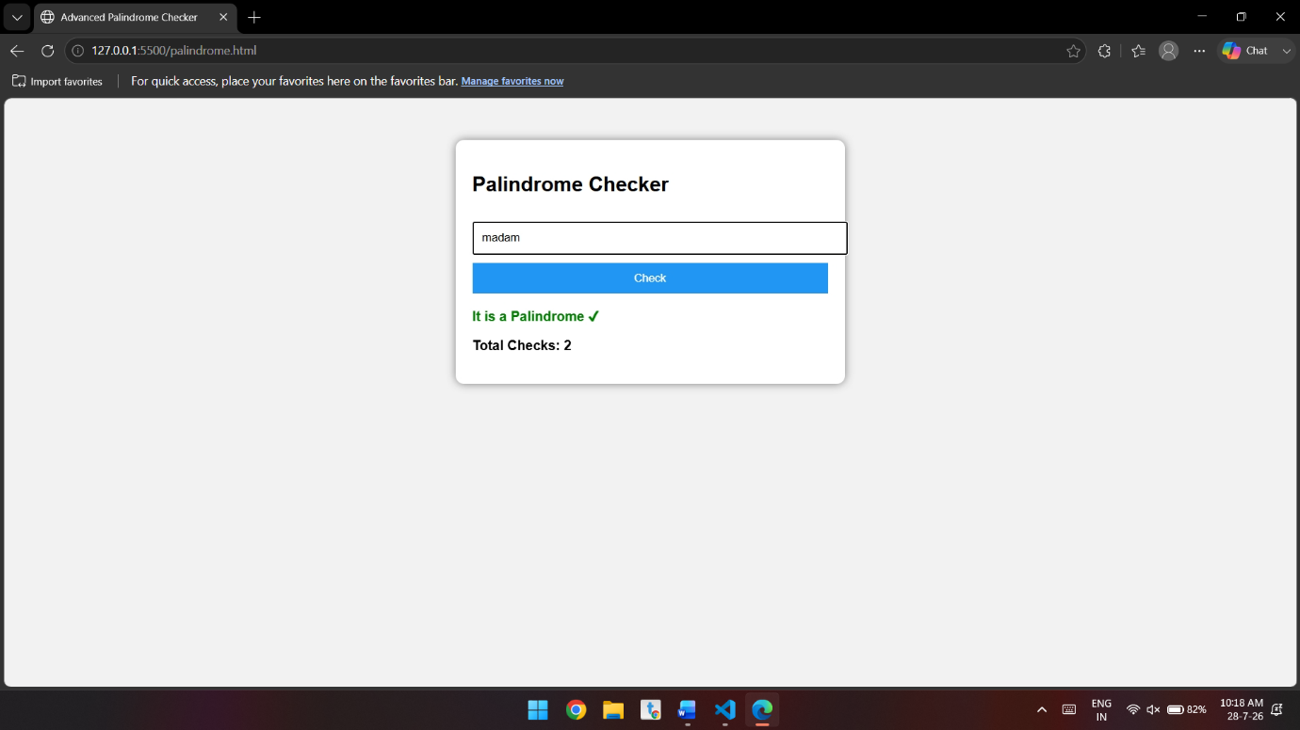

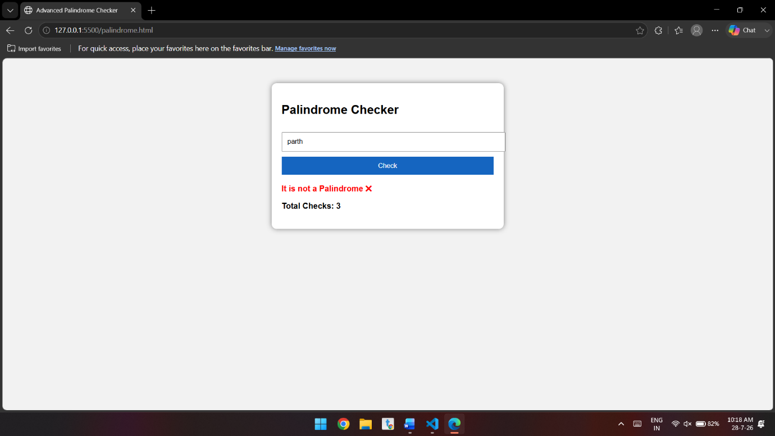

Conclusion:-
In this experiment, the concepts of function types, variable scope, closures, and exception handling were successfully studied and implemented. Different function types demonstrated flexible ways of organizing code, while scope rules controlled variable accessibility. Closures showed how functions can preserve access to outer variables, enabling data encapsulation and state management. The use of try-catch improved program reliability by handling errors effectively. Finally, the palindrome checker applied these concepts in a practical program, verifying whether a given input is a palindrome. Overall, the experiment strengthened the understanding of fundamental programming concepts and highlighted the importance of writing modular, maintainable, and error-resistant code.

Case study – 4
Aim:-
Real-Time Case Study: ATM Card PIN Verification Using JavaScript Functions to verify whether a customer's PIN is a palindrome. Use function declaration, function expression, arrow function, and demonstrate scope and closure concepts.

Software/Tools Required:-
- Visual Studio Code (or any text editor)
- Web Browser (Google Chrome/Microsoft Edge)
- HTML, CSS, and JavaScript

Code:-
<!DOCTYPE html>
<html lang="en">
<head>
<meta charset="UTF-8">
<meta name="viewport" content="width=device-width, initial-scale=1.0">

<title>ATM PIN Verification</title>

<style>
* {
box-sizing: border-box;
margin: 0;
padding: 0;
font-family: Arial, sans-serif;
}

body {
min-height: 100vh;
display: flex;
justify-content: center;
align-items: center;
background: linear-gradient(135deg, #0f2027, #203a43, #2c5364);
}

.atm-container {
width: 400px;
background: #ffffff;
border-radius: 18px;
padding: 30px;
box-shadow: 0 15px 40px rgba(0, 0, 0, 0.3);
}

.atm-header {
text-align: center;
margin-bottom: 25px;
}

.atm-header h1 {
color: #203a43;
margin-bottom: 8px;
}

.atm-header p {
color: #666;
font-size: 14px;
}

.form-group {
margin-bottom: 18px;
}

label {
display: block;
margin-bottom: 7px;
font-weight: bold;
color: #333;
}

input {
width: 100%;
padding: 13px;
border: 2px solid #ddd;
border-radius: 8px;
font-size: 16px;
outline: none;
}

input:focus {
border-color: #2c5364;
}

button {
width: 100%;
padding: 14px;
border: none;
border-radius: 8px;
background: #203a43;
color: white;
font-size: 16px;
font-weight: bold;
cursor: pointer;
transition: 0.2s;
}

button:hover {
background: #2c5364;
}

.result {
display: none;
margin-top: 25px;
padding: 20px;
border-radius: 10px;
}

.success {
display: block;
background: #e8f8ee;
border: 1px solid #38a169;
color: #155724;
}

.warning {
display: block;
background: #fff3cd;
border: 1px solid #ffc107;
color: #856404;
}

.transaction-info {
margin-top: 15px;
padding-top: 15px;
border-top: 1px solid currentColor;
}

.transaction-info p {
margin: 7px 0;
}

.access {
font-size: 20px;
font-weight: bold;
margin-bottom: 10px;
}

.attempt {
text-align: center;
margin-top: 18px;
color: #777;
font-size: 14px;
}

.reset-btn {
margin-top: 12px;
background: #777;
}

.reset-btn:hover {
background: #555;
}
</style>
</head>

<body>

<div class="atm-container">

<div class="atm-header">
<h1>🏦 ATM System</h1>
<p>PIN Verification System</p>
</div>

<div class="form-group">
<label for="accountHolder">Account Holder</label>
<input
type="text"
id="accountHolder"
placeholder="Enter your name"
>
</div>

<div class="form-group">
<label for="pin">Enter PIN</label>
<input
type="password"
id="pin"
placeholder="Enter any PIN"
inputmode="numeric"
>
</div>

<button onclick="verifyPin()">
Verify PIN
</button>

<div id="result" class="result"></div>

<p id="attemptDisplay" class="attempt">
Transaction Attempts: 0
</p>

<button class="reset-btn" onclick="resetATM()">
Reset
</button>

</div>

<script>

// ==========================================
// 1. FUNCTION DECLARATION
// ==========================================

// Utility function to reverse the entered PIN
function reversePin(pin) {
const pinStr = String(pin);

return pinStr
.split('')
.reverse()
.join('');
}

// ==========================================
// 2. CLOSURE & SCOPE DEMONSTRATION
// ==========================================

// ATM Session Generator
function createATMSession(accountHolder) {

// Outer lexical scope variable
const user = accountHolder;

// Private variable
let attempts = 0;

// ==========================================
// 3. ARROW FUNCTION
// Closure over `user` and `attempts`
// ==========================================

const verifyPinInteractive = (enteredPin) => {

attempts++;

// Remove extra spaces
const strEnteredPin = String(enteredPin).trim();

// Empty PIN
if (!strEnteredPin) {
return {
cancelled: true,
attempts: attempts
};
}

// Reverse PIN
const reversed = reversePin(strEnteredPin);

// Check palindrome
const isPalindrome =
strEnteredPin === reversed;

return {
user: user,
enteredPin: strEnteredPin,
reversed: reversed,
isPalindrome: isPalindrome,
attempts: attempts
};
};

// Return the inner function
return verifyPinInteractive;
}

// ==========================================
// 4. ATM SYSTEM
// ==========================================

let johnSession = null;

function verifyPin() {

const accountHolder =
document.getElementById("accountHolder").value.trim();

const pin =
document.getElementById("pin").value.trim();

const resultBox =
document.getElementById("result");

const attemptDisplay =
document.getElementById("attemptDisplay");

// Validate name
if (!accountHolder) {

resultBox.className = "result warning";

resultBox.innerHTML = `
<strong>Please enter the account holder's name.</strong>
`;

return;
}

// Create ATM session only once
if (!johnSession) {
johnSession = createATMSession(accountHolder);
}

// Validate PIN
if (!pin) {

resultBox.className = "result warning";

resultBox.innerHTML = `
<strong>Transaction cancelled.</strong>
<p>Please enter a PIN.</p>
`;

return;
}

// Call closure function
const transaction =
johnSession(pin);

// Display attempt count
attemptDisplay.innerText =
`Transaction Attempts: ${transaction.attempts}`;

// ==========================================
// PALINDROME DETECTED
// ==========================================

if (transaction.isPalindrome) {

resultBox.className = "result warning";

resultBox.innerHTML = `

<div class="access">
ACCESS GRANTED!
</div>

<p>
Welcome, ${transaction.user}.
</p>

<div class="transaction-info">

<p>
<strong>Entered PIN:</strong>
${transaction.enteredPin}
</p>

<p>
<strong>Reversed PIN:</strong>
${transaction.reversed}
</p>

<p>
<strong>Palindrome:</strong>
Yes
</p>

<br>

<strong>
⚠️ SPECIAL SECURITY ALERT
</strong>

<p>
Your PIN
"${transaction.enteredPin}"
is a palindrome.
Please consider changing your PIN
for better security.
</p>

</div>
`;
}

// ==========================================
// NORMAL PIN
// ==========================================

else {

resultBox.className = "result success";

resultBox.innerHTML = `

<div class="access">
ACCESS GRANTED!
</div>

<p>
Welcome, ${transaction.user}.
</p>

<div class="transaction-info">

<p>
<strong>Entered PIN:</strong>
${transaction.enteredPin}
</p>

<p>
<strong>Reversed PIN:</strong>
${transaction.reversed}
</p>

<p>
<strong>Palindrome:</strong>
No
</p>

<br>

<strong>
✅ PIN accepted successfully.
</strong>

</div>
`;
}
}

// ==========================================
// RESET ATM
// ==========================================

function resetATM() {

johnSession = null;

document.getElementById("accountHolder").value = "";
document.getElementById("pin").value = "";

const resultBox =
document.getElementById("result");

resultBox.className = "result";
resultBox.innerHTML = "";

document.getElementById("attemptDisplay")
.innerText = "Transaction Attempts: 0";
}

</script>

</body>
</html>

Theory:-
This case study demonstrates JavaScript functions, scope, closures, and palindrome checking through an ATM PIN verification system. The program reverses the entered PIN and compares it with the original PIN to check whether it is a palindrome. It uses a function declaration, an arrow function, and a closure to maintain the account holder and transaction attempt count.

Output:-
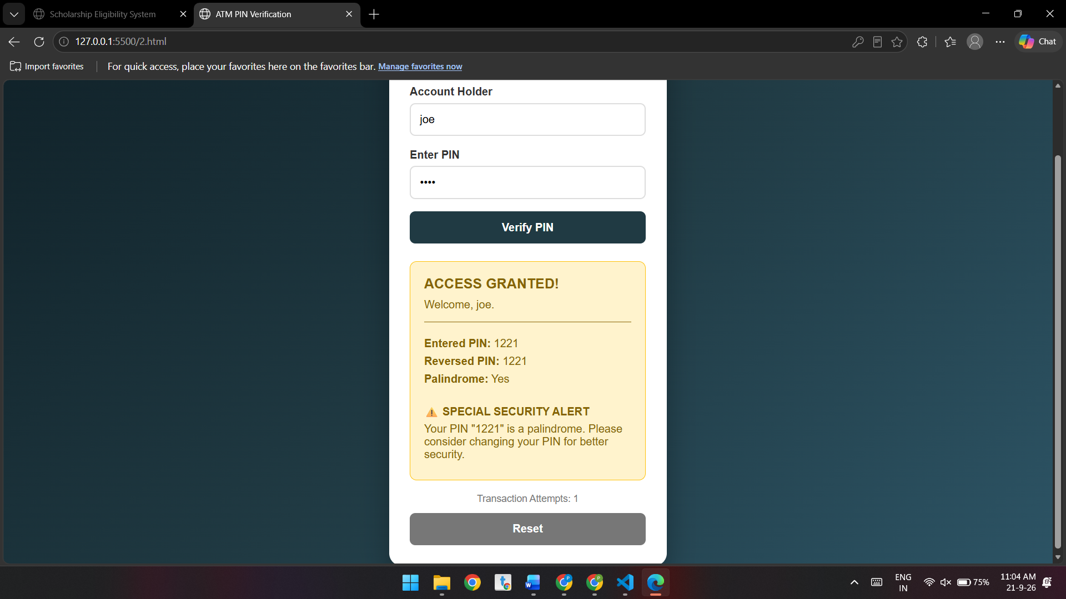

Conclusion:-
The ATM PIN Verification system successfully validates the entered PIN and checks whether it is a palindrome. It also demonstrates the practical use of functions, scope, closures, input validation, and transaction tracking in JavaScript. Thus, the project helps understand these concepts through a simple real-world ATM application.

Experiment – 5

Aim:-
Apply array methods and object handling; create a cart total calculator with discount logic.

Software/Tools Required:-
- Visual Studio Code (or any text editor)
- Web Browser (Google Chrome/Microsoft Edge)
- HTML, CSS, and JavaScript

Code:-
<!DOCTYPE html>
<html>
<head>
<title>Interactive Shopping Cart</title>
<style>
body{
font-family: Arial, sans-serif;
background:#f4f4f4;
}
.container{
width:450px;
margin:40px auto;
background:white;
padding:20px;
border-radius:10px;
box-shadow:0 0 10px gray;
text-align:center;
}
select,input,button{
padding:8px;
margin:8px;
}
table{
width:100%;
border-collapse:collapse;
margin-top:20px;
}
table,th,td{
border:1px solid #999;
}
th,td{
padding:8px;
}
th{
background:#4CAF50;
color:white;
}
#result{
margin-top:20px;
font-size:18px;
font-weight:bold;
}
</style>
</head>
<body>

<div class="container">
<h2>Shopping Cart Calculator</h2>

<label>Item:</label>
<select id="item">
<option value="800">Laptop ($800)</option>
<option value="25">Mouse ($25)</option>
<option value="50">Keyboard ($50)</option>
<option value="100">Headphones ($100)</option>
<option value="300">Monitor ($300)</option>
</select>

<br>

<label>Quantity:</label>
<input type="number" id="qty" min="1" placeholder="Enter quantity">

<br>

<button onclick="addToCart()">Add to Cart</button>
<button onclick="calculateBill()">Calculate Bill</button>
<button onclick="clearCart()">Clear Cart</button>

<table>
<thead>
<tr>
<th>Item</th>
<th>Price</th>
<th>Qty</th>
<th>Total</th>
</tr>
</thead>
<tbody id="cartTable"></tbody>
</table>

<div id="result"></div>
</div>

<script>

const cart = [];

function addToCart(){

let select = document.getElementById("item");
let name = select.options[select.selectedIndex].text.split(" (")[0];
let price = Number(select.value);
let qty = Number(document.getElementById("qty").value);

if(qty <= 0 || isNaN(qty)){
alert("Please enter a valid quantity.");
return;
}

cart.push({
name:name,
price:price,
quantity:qty
});

displayCart();

document.getElementById("qty").value="";
}

function displayCart(){

let table = document.getElementById("cartTable");
table.innerHTML="";

cart.forEach(item=>{

table.innerHTML += `
<tr>
<td>${item.name}</td>
<td>$${item.price}</td>
<td>${item.quantity}</td>
<td>$${item.price*item.quantity}</td>
</tr>`;

});

}

function calculateBill(){

if(cart.length===0){
alert("Cart is empty!");
return;
}

let total = cart.reduce((sum,item)=>sum+(item.price*item.quantity),0);

let discount=0;

if(total>=1000)
discount=total*0.20;
else if(total>=500)
discount=total*0.10;
else if(total>=200)
discount=total*0.05;

let finalAmount=total-discount;

document.getElementById("result").innerHTML=
`
Total : $${total.toFixed(2)} <br>
Discount : $${discount.toFixed(2)} <br>
<span style="color:green;">Final Amount : $${finalAmount.toFixed(2)}</span>
`;

}

function clearCart(){

cart.length=0;
document.getElementById("cartTable").innerHTML="";
document.getElementById("result").innerHTML="";
}

</script>

</body>
</html>

Theory:-
A cart total calculator in JavaScript can be implemented using arrays, objects, and array methods to manage products and calculate the final payable amount. Each product can be represented as an object containing properties such as product name, price, and quantity. An array stores all the product objects in the shopping cart.

Array methods make the calculation simpler and more efficient:-

map() can be used to calculate the subtotal of each product by multiplying its price by its quantity.
reduce() can calculate the total cart value by adding all product subtotals.
filter() can be used to identify products or conditions that meet specific requirements, if needed.
Object handling allows individual product details to be accessed and modified using properties such as price, quantity, and name.
Conditional statements can implement discount logic. For example, a percentage discount can be applied when the cart total exceeds a specified amount.
The final amount is calculated by subtracting the discount from the original cart total.

A typical calculation is:

Subtotal = Σ (Product Price × Quantity)

If the subtotal satisfies the discount condition:

Discount = Subtotal × Discount Rate

Final Total = Subtotal − Discount

Output:-
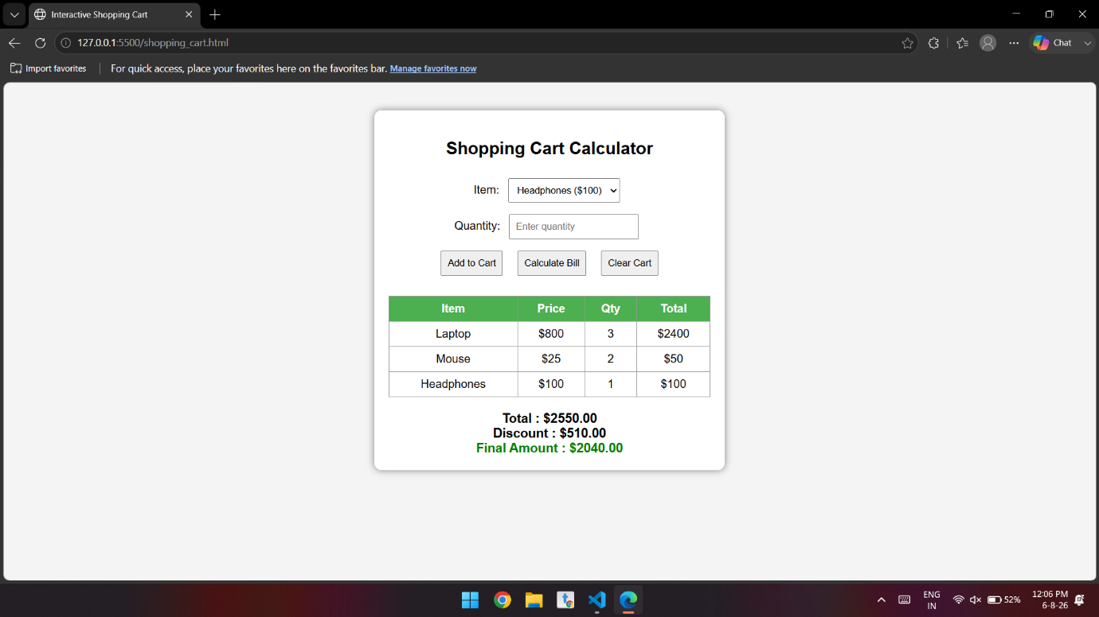

Conclusion:-
The experiment successfully demonstrates the use of arrays, objects, map(), reduce(), and conditional statements in JavaScript to create a cart total calculator. The program can calculate individual product subtotals, determine the overall cart value, and apply discounts according to predefined conditions. This provides a practical understanding of how array methods and object handling can be used to solve real-world programming problems while keeping the code organized, reusable, and efficient.

Case study – 5

Aim:-
To develop a JavaScript-based Array Calculator that accepts numbers from the user and finds the maximum and minimum values in the array.

Software/Tools Required:-
- Visual Studio Code (or any text editor)
- Web Browser (Google Chrome/Microsoft Edge)
- HTML, CSS, and JavaScript

Code:-
<!DOCTYPE html>
<html>
<head>
<title>Array Maximum and Minimum</title>

<style>
* {
box-sizing: border-box;
}

body {
font-family: Arial, sans-serif;
background: linear-gradient(135deg, #dff7f2, #cde9ff);
margin: 0;
padding: 0;
display: flex;
justify-content: center;
align-items: center;
min-height: 100vh;
}

.container {
background: rgba(255, 255, 255, 0.95);
width: 450px;
padding: 35px;
border-radius: 20px;

box-shadow:
0 15px 40px rgba(60, 120, 130, 0.18);

text-align: center;
}

h1 {
color: #17494d;
font-size: 30px;
margin-bottom: 10px;
}

p {
color: #6b7f82;
}

input {
width: 80%;
padding: 14px;
margin: 12px;
border: 2px solid #d5e8e6;
border-radius: 10px;

font-size: 16px;

background-color: #f7fcfb;
color: #17494d;

transition: 0.3s;
}

input:focus {
outline: none;
border-color: #52b8ae;

box-shadow:
0 0 0 3px rgba(82, 184, 174, 0.15);
}

input::placeholder {
color: #9aabab;
}

button {
padding: 12px 20px;
margin: 8px;

border: none;
border-radius: 10px;

background-color: #42a89d;
color: white;

font-size: 15px;
font-weight: 600;

cursor: pointer;

transition: 0.25s;
}

button:hover {
background-color: #328f86;
transform: translateY(-2px);

box-shadow:
0 6px 15px rgba(66, 168, 157, 0.25);
}

.result {
margin-top: 25px;
padding: 20px;

background-color: #f0faf8;

border: 1px solid #d6eeea;
border-radius: 14px;

display: none;
}

.result h3 {
color: #17494d;
margin-top: 0;
}

.maximum {
color: #23866d;
font-weight: bold;
}

.minimum {
color: #e06c5f;
font-weight: bold;
}
</style>
</head>

<body>

<div class="container">

<h1>Array Calculator</h1>

<p>Enter numbers separated by commas</p>

<input
type="text"
id="numbers"
placeholder="Example: 25, 10, 45, 5, 30, 15"
>

<br>

<button onclick="findMaxMin()">
Find Maximum & Minimum
</button>

<button onclick="clearData()">
Clear
</button>

<div class="result" id="result"></div>

</div>

<script>

function findMaxMin() {

// Get input from user
let input = document.getElementById("numbers").value;

// Check if input is empty
if (input.trim() === "") {
alert("Please enter some numbers!");
return;
}

// Convert input into an array
let numbers = input.split(",").map(Number);

// Check for invalid numbers
if (numbers.some(isNaN)) {
alert("Please enter only valid numbers!");
return;
}

// Find maximum and minimum
let maximum = numbers[0];
let minimum = numbers[0];

for (let i = 1; i < numbers.length; i++) {

if (numbers[i] > maximum) {
maximum = numbers[i];
}

if (numbers[i] < minimum) {
minimum = numbers[i];
}
}

// Display result
document.getElementById("result").style.display = "block";

document.getElementById("result").innerHTML =
"<h3>Result</h3>" +
"<p><b>Array:</b> [" + numbers.join(", ") + "]</p>" +
"<p class='maximum'>Maximum Value: " + maximum + "</p>" +
"<p class='minimum'>Minimum Value: " + minimum + "</p>";
}

function clearData() {

document.getElementById("numbers").value = "";

document.getElementById("result").style.display = "none";
}

</script>

</body>
</html>

Theory:-
An array is a collection of multiple values stored in a single variable. In this program, the input numbers are separated by commas and converted into an array using split() and map(Number). A for loop compares each element to find the maximum and minimum values. JavaScript functions are used to perform the calculation and clear the input data.

Output:-
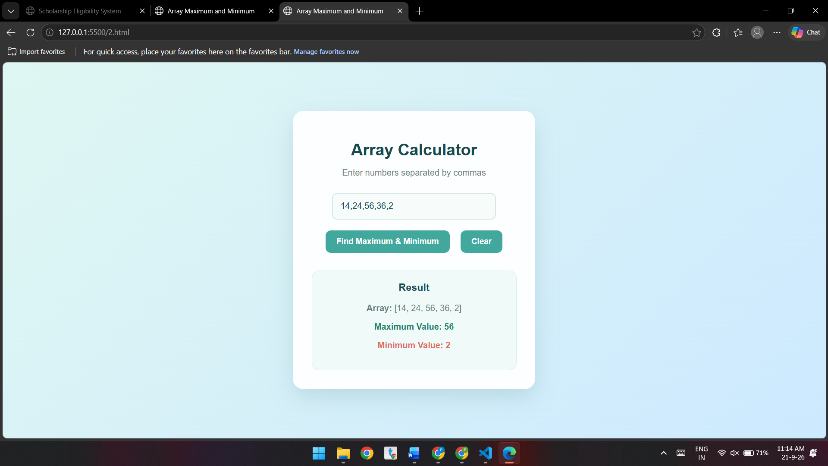

Conclusion:-
The program successfully accepts an array of numbers and calculates its maximum and minimum values using JavaScript. It also performs input validation and provides a clear and simple way to display the results.

Experiment – 6

Aim:-
Use string functions and regex for email validation, data extraction, and text analysis.

Software/Tools Required:-
- Visual Studio Code (or any text editor)
- Web Browser (Google Chrome/Microsoft Edge)
- HTML, CSS, and JavaScript

Code:-
<!DOCTYPE html>
<html lang="en">

<head>
<meta charset="UTF-8">
<meta name="viewport" content="width=device-width, initial-scale=1.0">

<title>String Functions and Regex</title>

<style>

body {
font-family: Arial, sans-serif;
background-color: #f2f2f2;
margin: 0;
padding: 30px;
}

/* Student Details Outside Main Box */
.details-box {
width: 250px;
border: 2px solid #333;
padding: 12px 18px;
border-radius: 8px;
background-color: white;
position: absolute;
top: 30px;
right: 30px;
box-shadow: 0 0 8px #ccc;
}

.details-box p {
margin: 6px 0;
font-size: 14px;
}

/* Main Project Box */
.container {
width: 700px;
max-width: 70%;
margin: 70px auto 0 auto;
background: white;
padding: 25px;
border-radius: 10px;
box-shadow: 0 0 10px #ccc;
}

h1 {
text-align: center;
color: #333;
}

h2 {
color: #444;
}

input,
textarea {
width: 100%;
padding: 10px;
margin: 8px 0;
border: 1px solid #ccc;
border-radius: 5px;
box-sizing: border-box;
}

textarea {
height: 130px;
resize: vertical;
}

button {
background-color: #333;
color: white;
border: none;
padding: 10px 15px;
border-radius: 5px;
cursor: pointer;
margin: 5px 5px 5px 0;
}

button:hover {
background-color: #555;
}

.result {
background-color: #f5f5f5;
padding: 12px;
margin-top: 10px;
border-radius: 5px;
white-space: pre-line;
}

.valid {
color: green;
font-weight: bold;
}

.invalid {
color: red;
font-weight: bold;
}

section {
margin-bottom: 30px;
}

</style>

</head>

<body>

<!-- STUDENT DETAILS BOX -->
<div class="details-box">

<p><strong>Name:</strong> Parth Jirapure</p>
<p><strong>Year:</strong> 3</p>
<p><strong>Sem:</strong> 5</p>
<p><strong>Sec:</strong> D</p>
<p><strong>PRN:</strong> 24070521243</p>

</div>

<!-- MAIN PROJECT BOX -->
<div class="container">

<h1>String Functions and Regular Expressions</h1>

<!-- EMAIL VALIDATION -->
<section>

<h2>1. Email Validation</h2>

<input
type="text"
id="email"
placeholder="Enter email address"
>

<button onclick="validateEmail()">
Validate Email
</button>

<div id="emailResult" class="result"></div>

</section>

<!-- DATA EXTRACTION -->
<section>

<h2>2. Data Extraction</h2>

<textarea
id="text"
placeholder="Enter text containing email addresses and phone numbers"
></textarea>

<button onclick="extractEmails()">
Extract Emails
</button>

<button onclick="extractPhones()">
Extract Phone Numbers
</button>

<div id="extractResult" class="result"></div>

</section>

<!-- TEXT ANALYSIS -->
<section>

<h2>3. Text Analysis</h2>

<textarea
id="analysisText"
placeholder="Enter text for analysis"
></textarea>

<button onclick="analyzeText()">
Analyze Text
</button>

<div id="analysisResult" class="result"></div>

</section>

</div>

<script>

// EMAIL VALIDATION

function validateEmail() {

let email =
document.getElementById("email").value;

let pattern =
/^[^\s@]+@[^\s@]+\.[^\s@]+$/;

let result =
document.getElementById("emailResult");

if (pattern.test(email)) {

result.innerHTML =
"<span class='valid'>Valid Email Address</span>";

} else {

result.innerHTML =
"<span class='invalid'>Invalid Email Address</span>";
}
}

// EMAIL EXTRACTION

function extractEmails() {

let text =
document.getElementById("text").value;

let pattern =
/[a-zA-Z0-9._%+-]+@[a-zA-Z0-9.-]+\.[a-zA-Z]{2,}/g;

let emails =
text.match(pattern);

let result =
document.getElementById("extractResult");

if (emails) {

result.innerText =
"Emails Found:\n\n" +
emails.join("\n");

} else {

result.innerText =
"No email addresses found.";
}
}

// PHONE NUMBER EXTRACTION

function extractPhones() {

let text =
document.getElementById("text").value;

let pattern =
/(?:\+91[-\s]?)?[6-9]\d{9}/g;

let phones =
text.match(pattern);

let result =
document.getElementById("extractResult");

if (phones) {

result.innerText =
"Phone Numbers Found:\n\n" +
phones.join("\n");

} else {

result.innerText =
"No phone numbers found.";
}
}

// TEXT ANALYSIS

function analyzeText() {

let text =
document.getElementById("analysisText").value;

if (text.trim() === "") {

document.getElementById("analysisResult").innerText =
"Please enter some text.";

return;
}

let characters =
text.length;

let words =
text.trim().split(/\s+/);

let sentences =
text.split(/[.!?]+/)
.filter(sentence =>
sentence.trim() !== ""
);

let uppercase =
text.toUpperCase();

let lowercase =
text.toLowerCase();

let result =
"TEXT ANALYSIS\n\n" +

"Characters: " +
characters + "\n" +

"Words: " +
words.length + "\n" +

"Sentences: " +
sentences.length + "\n\n" +

"Uppercase:\n" +
uppercase + "\n\n" +

"Lowercase:\n" +
lowercase;

document.getElementById("analysisResult").innerText =
result;
}

</script>

</body>

</html>

Theory:-
String functions are used to manipulate and analyze text data, while regular expressions (Regex) are patterns used to search, match, validate, and extract specific information from strings. In this experiment, both techniques are applied to perform three important operations.
1. Email Validation:
A regular expression is used to check whether an entered email address follows a valid format. A typical pattern verifies the username, the @ symbol, the domain name, and the domain extension. For example, an address such as parthjirapure@gmail.com matches the required pattern and is considered valid.
2. Data Extraction:
Regex can identify specific types of information within a larger text. In this experiment, regular expressions are used to extract email addresses and phone numbers from the given paragraph. Methods such as match(), matchAll(), or replace() can be combined with Regex patterns to locate the required data efficiently.
3. Text Analysis:
String functions can be used to calculate the number of characters, words, and sentences in a text. Functions such as length, split(), toUpperCase(), and toLowerCase() help process the text. The experiment also converts the input into uppercase and lowercase forms, demonstrating basic string transformation and analysis.

Output:-
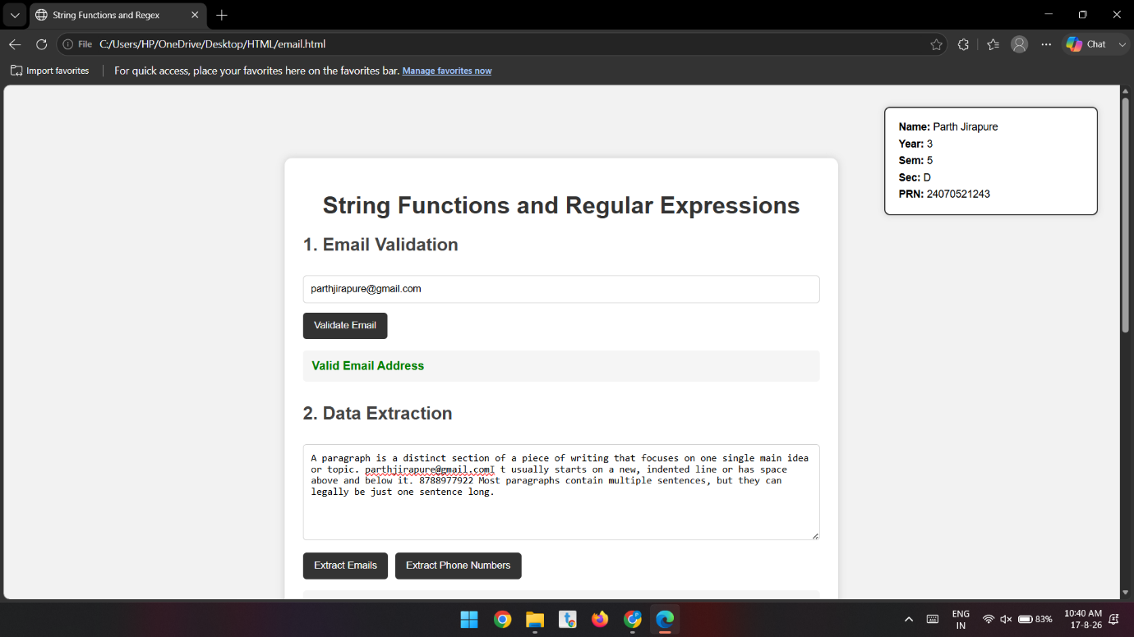
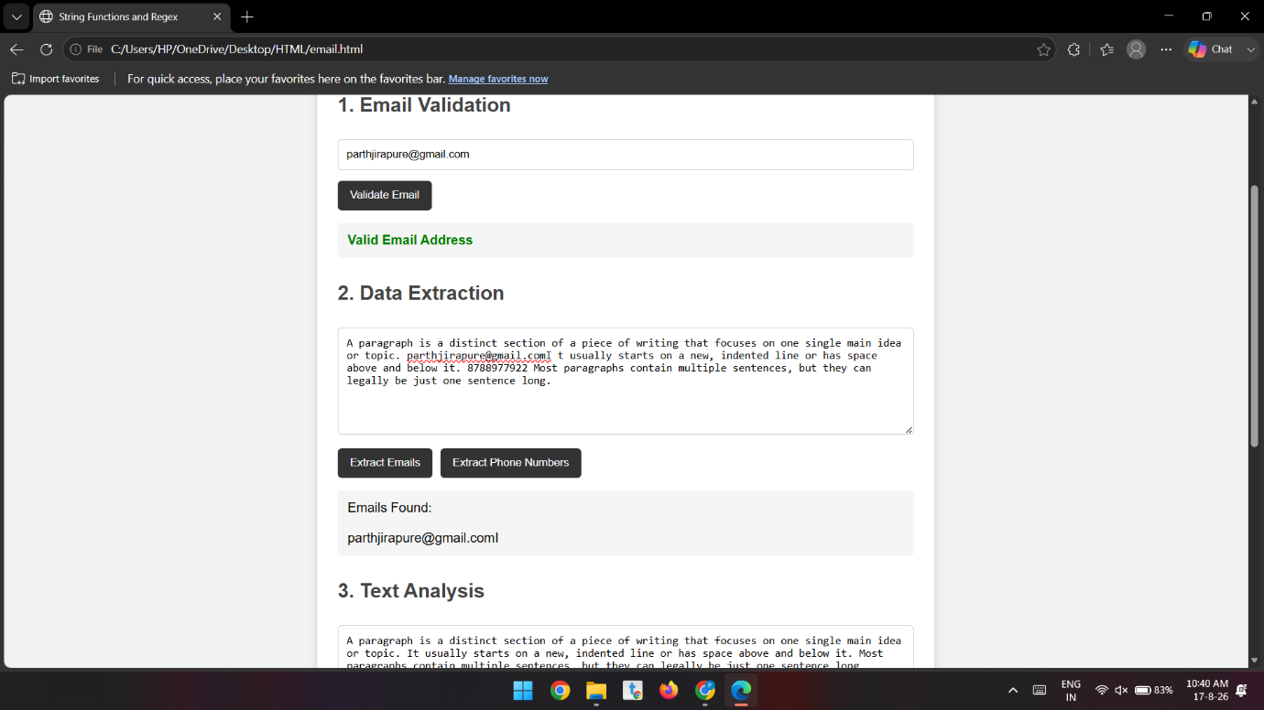
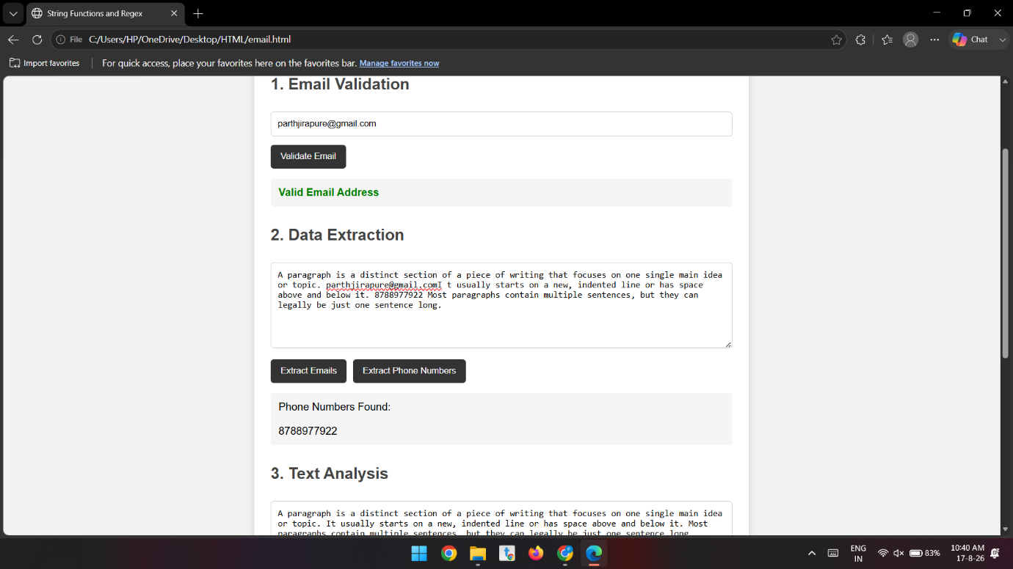

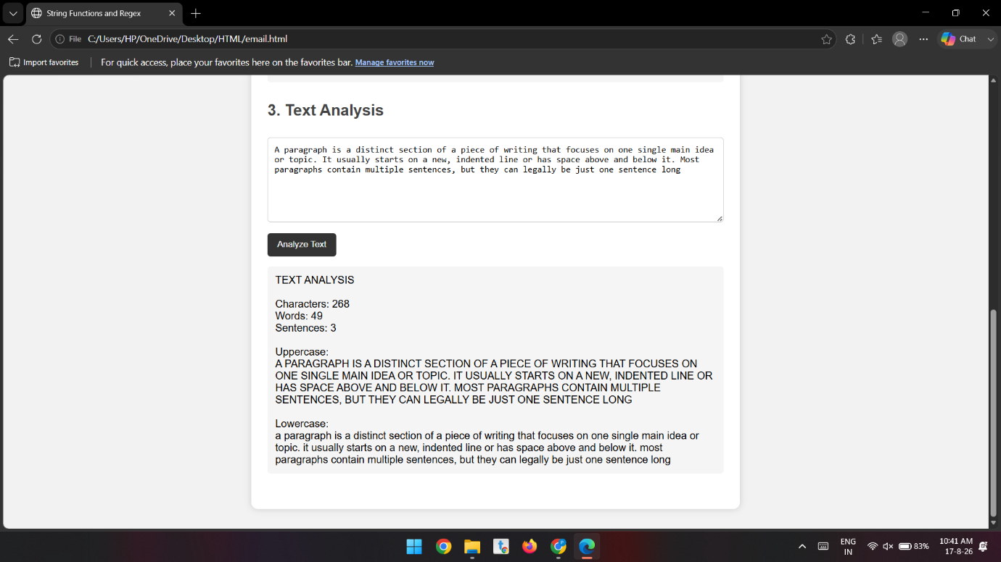

Conclusion:-
The experiment successfully demonstrated the use of string functions and regular expressions for email validation, data extraction, and text analysis. It showed that JavaScript provides efficient tools for processing and analyzing text data.

Case study – 6
Aim
To develop a JavaScript program for performing string operations, specifically to reverse a string and count the number of vowels present in a paragraph.

Software/Tools Required:-
- Visual Studio Code (or any text editor)
- Web Browser (Google Chrome/Microsoft Edge)
- HTML, CSS, and JavaScript

Code:-
<!DOCTYPE html>
<html>
<head>
<title>String Operations in JavaScript</title>

<style>
body {
font-family: Arial, sans-serif;
background-color: #f2f2f2;
margin: 0;
padding: 25px;
}

/* Main Content */
.container {
width: 700px;
max-width: 85%;
margin: auto;
}

h1 {
text-align: center;
color: #333;
margin-bottom: 25px;
}

/* Student Details Box on Right Side */
.student-details {
position: fixed;
top: 25px;
right: 15px;
width: 190px;
background-color: white;
padding: 15px;
border-radius: 8px;
box-shadow: 0 2px 8px #bbb;
border-right: 5px solid #4CAF50;
line-height: 1.7;
z-index: 10;
}

.student-details h3 {
margin-top: 0;
margin-bottom: 10px;
color: #4a4a4a;
border-bottom: 1px solid #ddd;
padding-bottom: 7px;
}

.student-details p {
margin: 3px 0;
font-size: 14px;
}

/* Task Boxes */
.box {
background-color: white;
padding: 20px;
margin-bottom: 20px;
border-radius: 8px;
box-shadow: 0 2px 8px #bbb;
}

h2 {
color: #4a4a4a;
margin-top: 0;
}

label {
font-weight: bold;
}

/* Input and Textarea */
input,
textarea {
width: 100%;
padding: 10px;
margin-top: 8px;
margin-bottom: 12px;
border: 1px solid #aaa;
border-radius: 5px;
box-sizing: border-box;
font-size: 15px;
}

textarea {
height: 120px;
resize: none;
}

/* Button */
button {
background-color: #4CAF50;
color: white;
border: none;
padding: 10px 18px;
border-radius: 5px;
cursor: pointer;
font-size: 15px;
}

button:hover {
background-color: #45a049;
}

/* Result */
.result {
margin-top: 15px;
padding: 10px;
background-color: #eeeeee;
border-radius: 5px;
color: #333;
min-height: 20px;
}

/* Footer */
.footer {
text-align: center;
margin-top: 25px;
color: #666;
}

/* For smaller screens */
@media (max-width: 1000px) {
.student-details {
position: static;
width: 700px;
max-width: 85%;
margin: 0 auto 20px auto;
box-sizing: border-box;
}

.container {
max-width: 90%;
}
}
</style>
</head>

<body>

<!-- Student Details -->
<div class="student-details">

<h3>Student Details</h3>

<p><b>Name:</b> Parth Jirapure</p>
<p><b>Year:</b> 3</p>
<p><b>Sem:</b> 5</p>
<p><b>Sec:</b> D</p>
<p><b>PRN:</b> 24070521243</p>

</div>

<!-- Main Content -->
<div class="container">

<h1>JavaScript String Operations</h1>

<!-- Task 1 -->
<div class="box">

<h2>1. Reverse a String</h2>

<label for="stringInput">
Enter a String:
</label>

<input
type="text"
id="stringInput"
placeholder="Enter a string"
>

<button onclick="reverseString()">
Reverse String
</button>

<div class="result">
<b>Result:</b>
<span id="reverseResult"></span>
</div>

</div>

<!-- Task 2 -->
<div class="box">

<h2>2. Count Number of Vowels</h2>

<label for="paragraphInput">
Enter a Paragraph:
</label>

<textarea
id="paragraphInput"
placeholder="Enter your paragraph"
></textarea>

<button onclick="countVowels()">
Count Vowels
</button>

<div class="result">
<b>Result:</b>
<span id="vowelResult"></span>
</div>

</div>

<div class="footer">
JavaScript Lab Program
</div>

</div>

<script>

// Function to reverse a string
function reverseString() {

var str = document.getElementById("stringInput").value;

if (str == "") {

document.getElementById("reverseResult").innerHTML =
"Please enter a string.";

return;
}

var reverse = "";

for (var i = str.length - 1; i >= 0; i--) {

reverse = reverse + str[i];

}

document.getElementById("reverseResult").innerHTML =
reverse;
}

// Function to count vowels
function countVowels() {

var paragraph =
document.getElementById("paragraphInput").value;

if (paragraph == "") {

document.getElementById("vowelResult").innerHTML =
"Please enter a paragraph.";

return;
}

var count = 0;

var vowels = "aeiouAEIOU";

for (var i = 0; i < paragraph.length; i++) {

if (vowels.indexOf(paragraph[i]) != -1) {

count++;

}
}

document.getElementById("vowelResult").innerHTML =
"Number of vowels = " + count;
}

</script>

</body>
</html>

Theory
Strings are sequences of characters that can be processed using JavaScript functions and loops. In this program, the reverseString() function uses a for loop to traverse the string from the last character to the first and create its reverse. The countVowels() function checks each character of the paragraph against the vowels a, e, i, o, u in both uppercase and lowercase and counts the matching characters.

Output:-
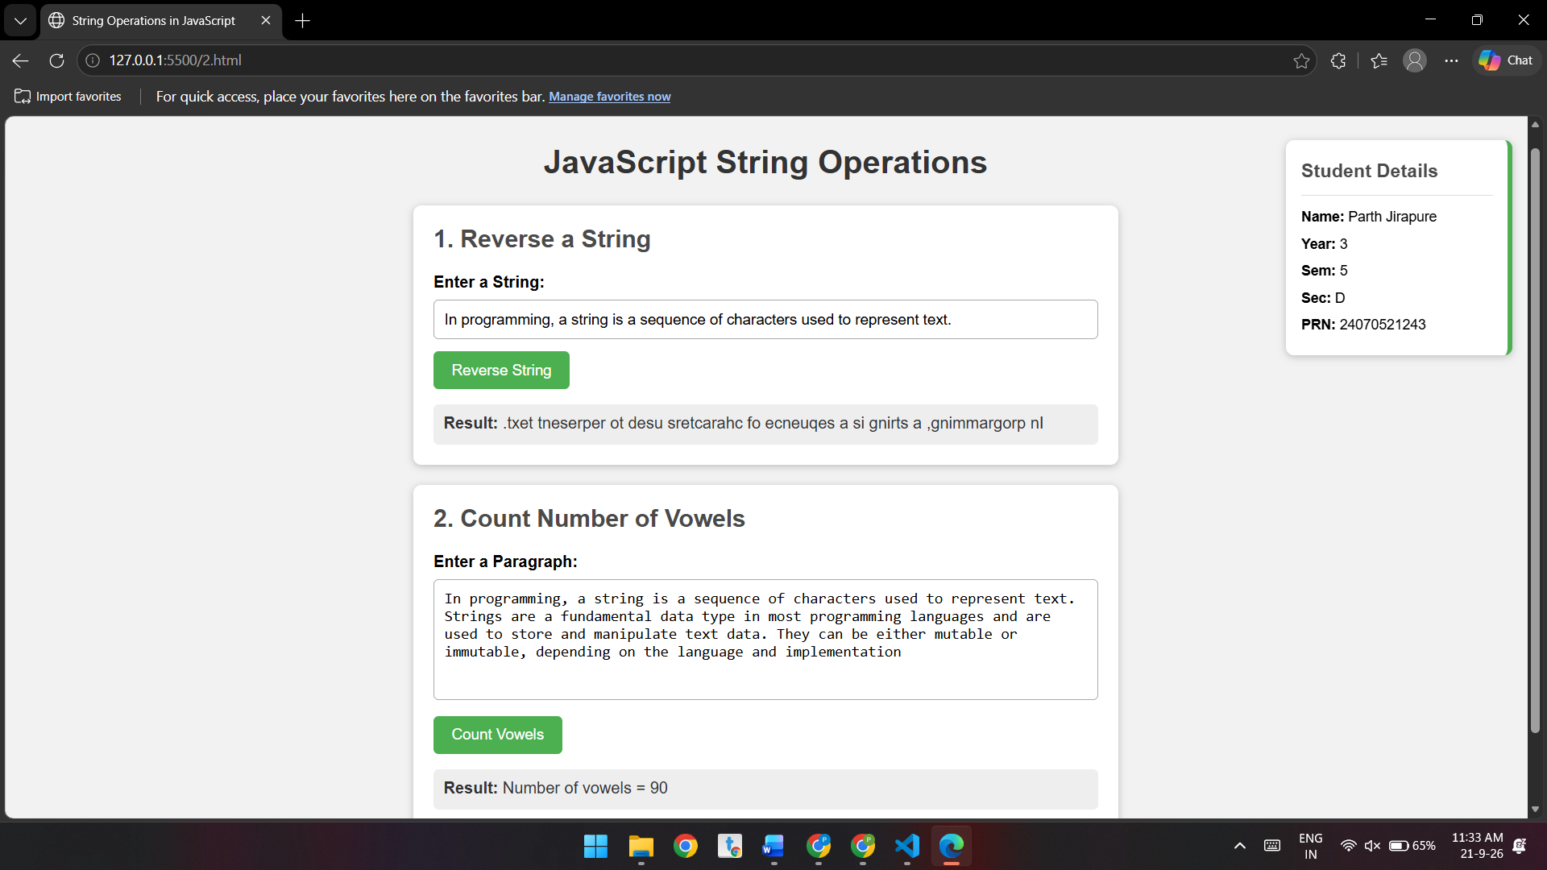

Conclusion
The program successfully performs basic string operations in JavaScript. It reverses the entered string and counts the number of vowels in a paragraph using functions and loops. It also displays a message when no input is provided, demonstrating basic input validation.

Experiment – 7

Aim:-
Perform DOM traversal and updates; develop a to-do list app with add, edit, and delete features.

Software/Tools Required:-
- Visual Studio Code (or any text editor)
- Web Browser (Google Chrome/Microsoft Edge)
- HTML, CSS, and JavaScript

Code:-
<!DOCTYPE html>
<html lang="en">

<head>
<meta charset="UTF-8">
<meta name="viewport" content="width=device-width, initial-scale=1.0">

<title>To-Do List - Internal JavaScript</title>

<style>

body {
font-family: Arial, sans-serif;
background-color: #f2f2f2;
margin: 0;
padding: 30px;
}

/* =========================
STUDENT DETAILS
TOP RIGHT - OUTSIDE TODO
========================= */

.student-details {
position: absolute;
top: 30px;
right: 40px;

width: 230px;

background-color: white;

padding: 20px;

border-radius: 10px;

box-shadow: 0 0 10px #aaa;
}

.student-details h2 {
margin-top: 0;
text-align: center;
color: #333;
}

.student-details p {
margin: 10px 0;
font-size: 15px;
}

/* =========================
TODO LIST
SEPARATE BOX
========================= */

.todo-container {
width: 550px;

margin: 100px auto 0 auto;

background-color: white;

padding: 30px;

border-radius: 10px;

box-shadow: 0 0 10px #aaa;
}

.todo-container h1 {
text-align: center;
color: #333;
}

/* Input Area */

.input-area {
display: flex;

gap: 10px;

margin-top: 20px;
}

#taskInput {
flex: 1;

padding: 12px;

font-size: 16px;

border: 1px solid #ccc;

border-radius: 5px;
}

/* Buttons */

button {
padding: 10px 15px;

border: none;

border-radius: 5px;

cursor: pointer;

font-size: 14px;
}

/* Add Button */

#addBtn {
background-color: green;

color: white;
}

#addBtn:hover {
background-color: darkgreen;
}

/* Task List */

ul {
list-style: none;

padding: 0;

margin-top: 20px;
}

li {
display: flex;

align-items: center;

justify-content: space-between;

padding: 12px;

margin-bottom: 10px;

background-color: #eee;

border-radius: 5px;
}

.task-text {
flex: 1;

cursor: pointer;
}

/* Completed Task */

.completed {
text-decoration: line-through;

color: gray;
}

/* Complete Button */
.complete-btn {
background-color: #2e7d32;
color: white;
margin-right: 5px;
font-size: 18px;
padding: 7px 12px;
}

.complete-btn:hover {
background-color: #1b5e20;
}

/* Edit Button */

.edit-btn {
background-color: orange;

color: white;

margin-right: 5px;
}

.edit-btn:hover {
background-color: darkorange;
}

/* Delete Button */

.delete-btn {
background-color: red;

color: white;
}

.delete-btn:hover {
background-color: darkred;
}

/* =========================
RESPONSIVE DESIGN
========================= */

@media (max-width: 800px) {

.student-details {
position: static;

width: auto;

margin-bottom: 30px;
}

.todo-container {
width: auto;

margin: 20px auto;
}

}

</style>

</head>

<body>

<!-- ==================================
STUDENT DETAILS
OUTSIDE TODO LIST
TOP RIGHT CORNER
================================== -->

<div class="student-details">

<h2>Student Details</h2>

<p>
<b>Name :</b> Parth Jirapure
</p>

<p>
<b>PRN :</b> 24070521243
</p>

<p>
<b>Semester :</b> 5th
</p>

<p>
<b>Section :</b> D
</p>

</div>

<!-- ==================================
TODO LIST
SEPARATE CONTAINER
================================== -->

<div class="todo-container">

<h1>To-Do List</h1>

<!-- Input Area -->

<div class="input-area">

<input
type="text"
id="taskInput"
placeholder="Enter a task"
>

<button id="addBtn">
Add
</button>

</div>

<!-- Task List -->

<ul id="taskList">

</ul>

</div>

<!-- ==================================
INTERNAL JAVASCRIPT
================================== -->

<script>

// ================================
// DOM TRAVERSAL
// ================================

const taskInput =
document.getElementById("taskInput");

const addBtn =
document.getElementById("addBtn");

const taskList =
document.getElementById("taskList");

// ================================
// ADD BUTTON EVENT
// ================================

addBtn.addEventListener(
"click",
addTask
);

// ================================
// ENTER KEY EVENT
// ================================

taskInput.addEventListener(
"keypress",
function(event) {

if (event.key === "Enter") {

addTask();

}

}
);

// ================================
// ADD TASK FUNCTION
// ================================

function addTask() {

// Get task from input

const task =
taskInput.value.trim();

// Check empty input

if (task === "") {

alert("Please enter a task.");

return;

}

// ================================
// CREATE LIST ITEM
// ================================

const li =
document.createElement("li");

// ================================
// CREATE TASK TEXT
// ================================

const span =
document.createElement("span");

span.className =
"task-text";

span.textContent =
task;

// ================================
// COMPLETE TASK
// ================================

span.addEventListener(
"click",
function() {

span.classList.toggle(
"completed"
);

}
);

// ================================
// CREATE COMPLETE BUTTON
// ================================

const completeBtn =
document.createElement("button");

completeBtn.textContent = "✓";
completeBtn.className = "complete-btn";

completeBtn.addEventListener(
"click",
function() {
span.classList.toggle("completed");
}
);

// ================================
// CREATE EDIT BUTTON
// ================================

const editBtn =
document.createElement("button");

editBtn.textContent =
"Edit";

editBtn.className =
"edit-btn";

editBtn.addEventListener(
"click",
function() {

// DOM Traversal

const taskText =
li.querySelector(
".task-text"
);

// Ask user for new task

const newTask =
prompt(
"Edit your task:",
taskText.textContent
);

// DOM Update

if (
newTask !== null &&
newTask.trim() !== ""
) {

taskText.textContent =
newTask.trim();

}

}
);

// ================================
// CREATE DELETE BUTTON
// ================================

const deleteBtn =
document.createElement("button");

deleteBtn.textContent =
"Delete";

deleteBtn.className =
"delete-btn";

deleteBtn.addEventListener(
"click",
function() {

// DOM Update

taskList.removeChild(li);

}
);

// ================================
// BUTTON CONTAINER
// ================================

const buttons =
document.createElement("div");

buttons.appendChild(completeBtn);
buttons.appendChild(editBtn);
buttons.appendChild(deleteBtn);

// ================================
// ADD ELEMENTS TO LI
// ================================

li.appendChild(span);

li.appendChild(buttons);

// ================================
// ADD LI TO TASK LIST
// ================================

taskList.appendChild(li);

// ================================
// CLEAR INPUT
// ================================

taskInput.value = "";

taskInput.focus();

}

</script>

</body>

</html>

Theory:-
The Document Object Model (DOM) is a programming interface that represents an HTML document as a tree of elements. JavaScript can use the DOM to access, traverse, modify, create, and delete HTML elements dynamically. DOM manipulation makes web pages interactive by allowing their content and appearance to change in response to user actions without reloading the page.

In this experiment, DOM traversal and manipulation are used to develop an interactive **To-Do List application**. The application allows the user to add new tasks, edit existing tasks, delete unwanted tasks, and mark tasks as completed. JavaScript is used to select HTML elements, create new elements, update their content, and remove elements from the document.

Event handling is used to detect actions such as clicking the **Add, Edit, Delete, and Check** buttons. When a task is completed, a visual change such as a strikethrough is applied to indicate its completed status. The user can also modify tasks whenever required, making the application simple and flexible to use.

This experiment demonstrates how DOM methods and JavaScript event handling can work together to create a dynamic and user-friendly web application. It provides practical understanding of how webpage elements can be controlled and updated based on user interaction.

Output:-
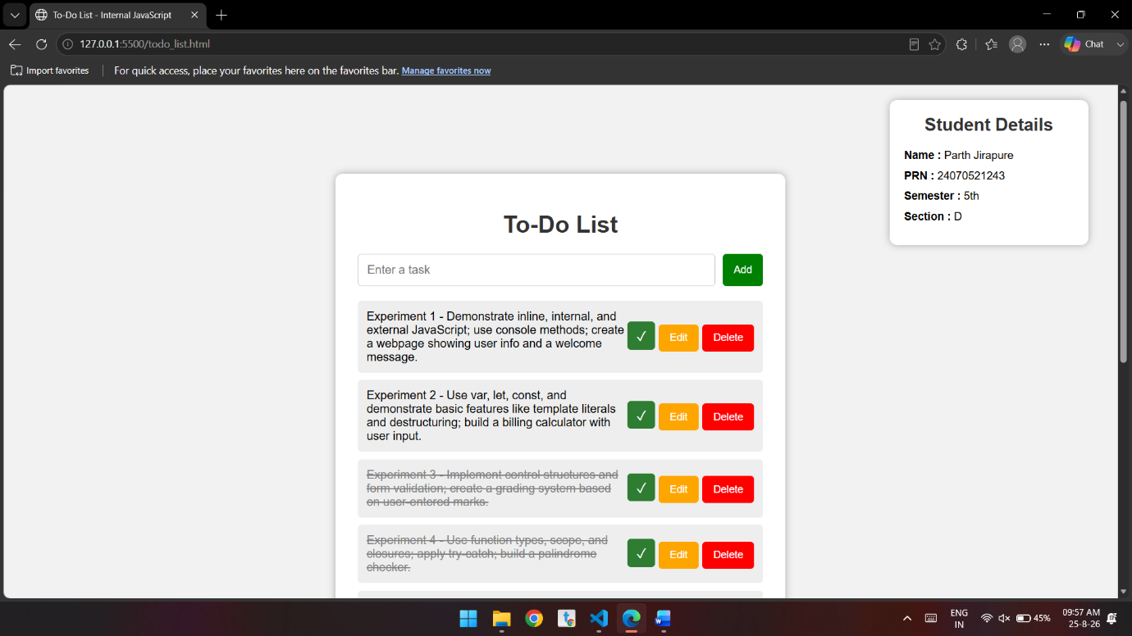
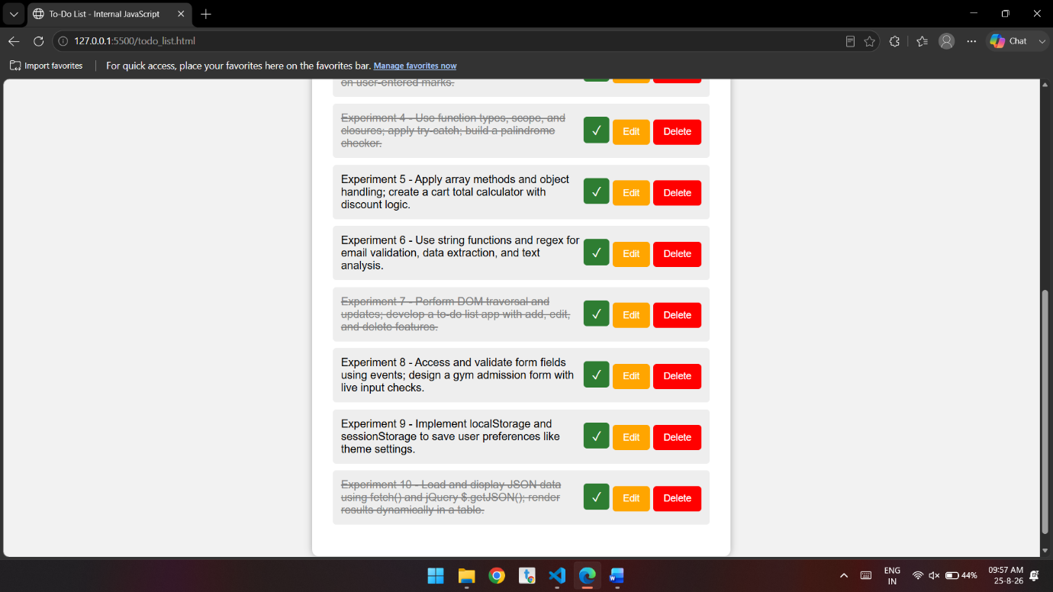

Conclusion:-
The To-Do List application was successfully implemented using HTML, CSS, and JavaScript. It demonstrated **DOM manipulation and event handling** through add, edit, delete, and complete features. The experiment helped in understanding how JavaScript creates dynamic and interactive web pages.

Case Study – 7
Aim
To develop a JavaScript-based registration form that accepts user details and performs validation for required fields, birthday, email, website, password, and terms and conditions.

Software/Tools Required:-
- Visual Studio Code (or any text editor)
- Web Browser (Google Chrome/Microsoft Edge)
- HTML, CSS, and JavaScript

Code:-
<!DOCTYPE html>
<html lang="en">
<head>
<meta charset="UTF-8">
<meta name="viewport" content="width=device-width, initial-scale=1.0">
<title>Form Handling with JavaScript</title>

<style>
body {
font-family: Arial, sans-serif;
margin: 30px;
background: linear-gradient(135deg, #e0f2fe, #ede9fe);
color: #1e293b;
}

.form-container {
border: none;
width: 450px;
padding: 25px;
box-sizing: border-box;
background-color: #ffffff;
border-radius: 12px;
box-shadow: 0 8px 25px rgba(30, 64, 175, 0.15);
}

.mandatory-note {
color: #dc2626;
font-size: 13px;
margin-bottom: 15px;
font-weight: bold;
}

.form-row {
display: flex;
align-items: center;
margin-bottom: 12px;
}

.form-row label {
width: 110px;
font-size: 14px;
color: #334155;
font-weight: 600;
}

.form-row input[type="text"],
.form-row input[type="email"],
.form-row input[type="url"],
.form-row input[type="password"],
.form-row select {
padding: 7px;
border: 1px solid #cbd5e1;
border-radius: 5px;
background-color: #f8fafc;
color: #1e293b;
box-sizing: border-box;
}

.input-field {
width: 180px;
}

.asterisk {
color: #ef4444;
margin-left: 4px;
font-weight: bold;
}

.date-selects select {
margin-right: 2px;
}

.checkbox-row {
display: flex;
align-items: center;
margin-top: 18px;
margin-bottom: 18px;
}

.checkbox-row input {
accent-color: #4f46e5;
cursor: pointer;
}

.checkbox-row label {
margin-left: 5px;
font-size: 14px;
color: #475569;
}

.submit-btn {
padding: 8px 20px;
font-weight: bold;
cursor: pointer;
border: none;
border-radius: 6px;
background: linear-gradient(135deg, #4f46e5, #2563eb);
color: white;
transition: 0.3s;
}

.submit-btn:hover {
background: linear-gradient(135deg, #4338ca, #1d4ed8);
transform: translateY(-1px);
}

/* Input highlighting on focus */
input:focus,
select:focus {
background-color: #eff6ff;
outline: 2px solid #6366f1;
border-color: #6366f1;
}

/* Responsive design */
@media (max-width: 500px) {
body {
margin: 15px;
}

.form-container {
width: 100%;
}

.form-row label {
width: 100px;
}

.input-field {
width: 160px;
}
}
</style>
</head>

<body>

<div class="form-container">

<div class="mandatory-note">*Mandatory to fill</div>

<form id="signupForm" novalidate>

<!-- Firstname -->
<div class="form-row">
<label for="firstname">Firstname:</label>
<input
type="text"
id="firstname"
class="input-field"
>
<span class="asterisk">*</span>
</div>

<!-- Lastname -->
<div class="form-row">
<label for="lastname">Lastname:</label>
<input
type="text"
id="lastname"
class="input-field"
>
</div>

<!-- Birthday -->
<div class="form-row">
<label>Birthday:</label>

<div class="date-selects">

<select id="day">
<option value="">Day</option>
</select>

<select id="month">
<option value="">Month</option>
<option value="1">Jan</option>
<option value="2">Feb</option>
<option value="3">Mar</option>
<option value="4">Apr</option>
<option value="5">May</option>
<option value="6">Jun</option>
<option value="7">Jul</option>
<option value="8">Aug</option>
<option value="9">Sep</option>
<option value="10">Oct</option>
<option value="11">Nov</option>
<option value="12">Dec</option>
</select>

<select id="year">
<option value="">Year</option>
</select>

</div>

<span class="asterisk">*</span>
</div>

<!-- Username -->
<div class="form-row">
<label for="username">Username:</label>
<input
type="text"
id="username"
class="input-field"
>
<span class="asterisk">*</span>
</div>

<!-- Email -->
<div class="form-row">
<label for="email">E-mail:</label>
<input
type="email"
id="email"
class="input-field"
>
<span class="asterisk">*</span>
</div>

<!-- Website -->
<div class="form-row">
<label for="website">Website:</label>
<input
type="url"
id="website"
class="input-field"
>
<span class="asterisk">*</span>
</div>

<!-- Password -->
<div class="form-row">
<label for="password">Password:</label>
<input
type="password"
id="password"
class="input-field"
>
<span class="asterisk">*</span>
</div>

<!-- Re-password -->
<div class="form-row">
<label for="repassword">Re-password:</label>
<input
type="password"
id="repassword"
class="input-field"
>
<span class="asterisk">*</span>
</div>

<!-- Terms -->
<div class="checkbox-row">
<input type="checkbox" id="terms">

<label for="terms">
I agree to the terms & conditions.
</label>
</div>

<!-- Submit -->
<button type="submit" class="submit-btn">
Sign up
</button>

</form>
</div>

<script>

// ==========================================
// Populate Days (1 to 31)
// ==========================================

const daySelect = document.getElementById("day");

for (let i = 1; i <= 31; i++) {

const opt = document.createElement("option");

opt.value = i;
opt.textContent = i;

daySelect.appendChild(opt);
}

// ==========================================
// Populate Years (1950 to 2026)
// ==========================================

const yearSelect = document.getElementById("year");

for (let i = 2026; i >= 1950; i--) {

const opt = document.createElement("option");

opt.value = i;
opt.textContent = i;

yearSelect.appendChild(opt);
}

// ==========================================
// Month Change Event
// ==========================================

document.getElementById("month").addEventListener("change", function () {

console.log("Month changed to: " + this.value);

});

// ==========================================
// Form Submit Event
// ==========================================

document.getElementById("signupForm").addEventListener("submit", function (e) {

e.preventDefault();

// Get form values

const firstname =
document.getElementById("firstname").value.trim();

const day =
document.getElementById("day").value;

const month =
document.getElementById("month").value;

const year =
document.getElementById("year").value;

const username =
document.getElementById("username").value.trim();

const email =
document.getElementById("email").value.trim();

const website =
document.getElementById("website").value.trim();

const password =
document.getElementById("password").value;

const repassword =
document.getElementById("repassword").value;

const terms =
document.getElementById("terms").checked;

// ==========================================
// Firstname Validation
// ==========================================

if (!firstname) {

alert("Firstname is required.");

return;
}

// ==========================================
// Birthday Validation
// ==========================================

if (!day || !month || !year) {

alert("Please select a complete birthday.");

return;
}

// ==========================================
// Username Validation
// ==========================================

if (!username) {

alert("Username is required.");

return;
}

// ==========================================
// Email Validation
// ==========================================

const emailRegex =
/^[^\s@]+@[^\s@]+\.[^\s@]+$/;

if (!emailRegex.test(email)) {

alert("Please enter a valid email address.");

return;
}

// ==========================================
// Website Validation
// ==========================================

const urlRegex =
/^(https?:\/\/)?([\w\d-]+\.)+[\w-]+(\/.*)?$/i;

if (!urlRegex.test(website)) {

alert("Please enter a valid website URL.");

return;
}

// ==========================================
// Password Validation
// ==========================================

if (!password) {

alert("Password is required.");

return;
}

// ==========================================
// Password Match Validation
// ==========================================

if (password !== repassword) {

alert("Passwords do not match.");

return;
}

// ==========================================
// Terms & Conditions Validation
// ==========================================

if (!terms) {

alert("You must agree to the terms & conditions.");

return;
}

// ==========================================
// Success Message
// ==========================================

alert("Form submitted successfully!");

});

</script>

</body>
</html>

Theory
Form handling in JavaScript is used to collect and validate user input before submission. This program uses HTML form elements such as text boxes, dropdowns, password fields, and a checkbox. JavaScript retrieves the entered values and validates them using conditions and regular expressions. It checks required fields, validates the email and website format, confirms that both passwords match, and verifies that the terms and conditions are accepted.

Output:-
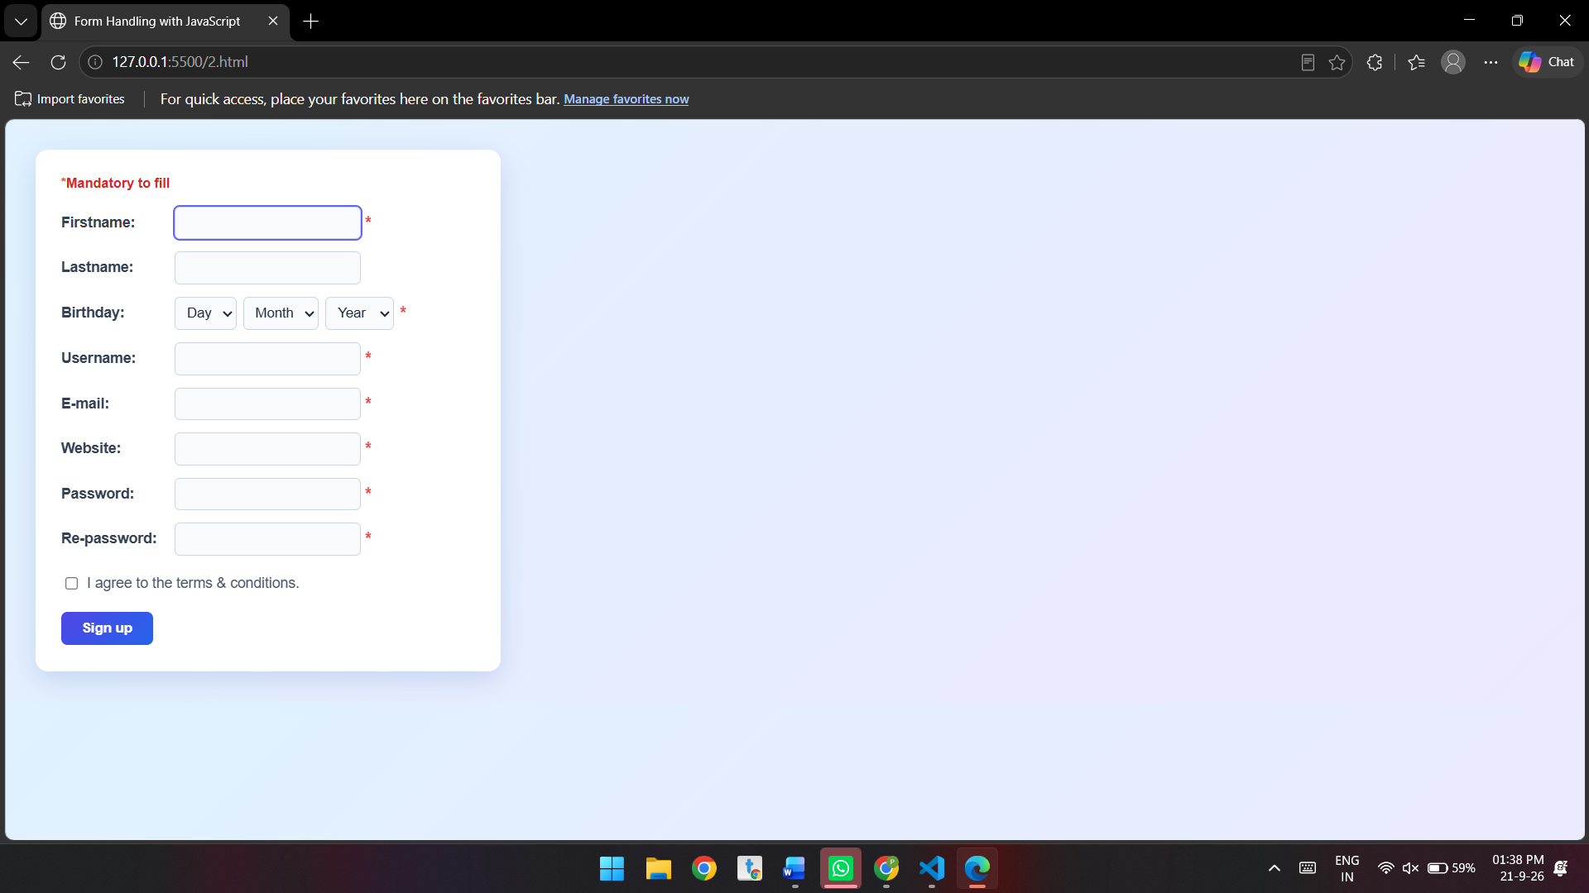

Conclusion
The program successfully implements a user registration form with JavaScript validation. It prevents incorrect or incomplete data from being submitted and displays appropriate messages for invalid inputs. This demonstrates the practical use of form handling, event handling, input validation, conditions, and regular expressions in JavaScript.

Experiment – 8

Aim:-
Access and validate form fields using events; design a gym admission form with live input checks.

Software/Tools Required:-
- Visual Studio Code (or any text editor)
- Web Browser (Google Chrome/Microsoft Edge)
- HTML, CSS, and JavaScript

Code:-
<!DOCTYPE html>
<html lang="en">
<head>
<meta charset="UTF-8">
<meta name="viewport" content="width=device-width, initial-scale=1.0">
<title>Gym Admission Form</title>

<!-- Internal CSS -->
<style>
body {
font-family: Arial, sans-serif;
background-color: #f2f2f2;
margin: 0;
padding: 40px;
}

/* Student details at top-right */
.student-details {
position: absolute;
top: 20px;
right: 30px;
background-color: white;
padding: 10px 15px;
border: 1px solid #ccc;
border-radius: 5px;
box-shadow: 0 0 5px rgba(0, 0, 0, 0.15);
font-size: 14px;
}

.student-details p {
margin: 5px 0;
}

/* Form container */
.container {
width: 400px;
margin: 100px auto 0;
background-color: white;
padding: 25px;
border-radius: 10px;
box-shadow: 0 0 10px rgba(0, 0, 0, 0.2);
}

h2 {
text-align: center;
color: #333;
}

label {
display: block;
margin-top: 15px;
font-weight: bold;
}

input,
select {
width: 100%;
padding: 10px;
margin-top: 5px;
box-sizing: border-box;
border: 1px solid #aaa;
border-radius: 5px;
}

input.valid,
select.valid {
border: 2px solid green;
}

input.invalid,
select.invalid {
border: 2px solid red;
}

.error {
color: red;
font-size: 13px;
margin-top: 4px;
}

button {
width: 100%;
margin-top: 20px;
padding: 12px;
background-color: #333;
color: white;
border: none;
border-radius: 5px;
cursor: pointer;
}

button:hover {
background-color: #555;
}

#success {
color: green;
text-align: center;
font-weight: bold;
margin-top: 15px;
}
</style>
</head>

<body>

<!-- Student Details -->
<div class="student-details">
<p><strong>Name:</strong> Parth Jirapure</p>
<p><strong>Year:</strong> 3</p>
<p><strong>Sem:</strong> 5</p>
<p><strong>Sec:</strong> D</p>
<p><strong>PRN:</strong> 24070521243</p>
</div>

<!-- Gym Admission Form -->
<div class="container">
<h2>Gym Admission Form</h2>

<form id="gymForm">

<label for="fullName">Full Name</label>
<input type="text" id="fullName"
placeholder="Enter your full name">
<div id="nameError" class="error"></div>

<label for="email">Email</label>
<input type="email" id="email"
placeholder="Enter your email">
<div id="emailError" class="error"></div>

<label for="mobile">Mobile Number</label>
<input type="text" id="mobile"
placeholder="Enter 10-digit mobile number">
<div id="mobileError" class="error"></div>

<label for="age">Age</label>
<input type="number" id="age"
placeholder="Enter your age">
<div id="ageError" class="error"></div>

<label for="plan">Membership Plan</label>
<select id="plan">
<option value="">-- Select Plan --</option>
<option value="Monthly">Monthly</option>
<option value="Quarterly">Quarterly</option>
<option value="Yearly">Yearly</option>
</select>
<div id="planError" class="error"></div>

<button type="submit">Submit Admission</button>

<div id="success"></div>

</form>
</div>

<!-- Internal JavaScript -->
<script>

// Access form fields
const form = document.getElementById("gymForm");
const fullName = document.getElementById("fullName");
const email = document.getElementById("email");
const mobile = document.getElementById("mobile");
const age = document.getElementById("age");
const plan = document.getElementById("plan");

// Full Name validation using input event
fullName.addEventListener("input", function () {

const error = document.getElementById("nameError");

if (fullName.value.trim().length < 3) {

error.textContent =
"Name must contain at least 3 characters.";

fullName.classList.add("invalid");
fullName.classList.remove("valid");

} else {

error.textContent = "";

fullName.classList.add("valid");
fullName.classList.remove("invalid");
}
});

// Email validation using input event
email.addEventListener("input", function () {

const error = document.getElementById("emailError");

const emailPattern =
/^[^ ]+@[^ ]+\.[a-z]{2,3}$/;

if (!emailPattern.test(email.value.trim())) {

error.textContent =
"Enter a valid email address.";

email.classList.add("invalid");
email.classList.remove("valid");

} else {

error.textContent = "";

email.classList.add("valid");
email.classList.remove("invalid");
}
});

// Mobile number validation using input event
mobile.addEventListener("input", function () {

const error = document.getElementById("mobileError");

const mobilePattern = /^[0-9]{10}$/;

if (!mobilePattern.test(mobile.value)) {

error.textContent =
"Mobile number must contain exactly 10 digits.";

mobile.classList.add("invalid");
mobile.classList.remove("valid");

} else {

error.textContent = "";

mobile.classList.add("valid");
mobile.classList.remove("invalid");
}
});

// Age validation using input event
age.addEventListener("input", function () {

const error = document.getElementById("ageError");

const ageValue = Number(age.value);

if (age.value === "" ||
ageValue < 16 ||
ageValue > 80) {

error.textContent =
"Age must be between 16 and 80.";

age.classList.add("invalid");
age.classList.remove("valid");

} else {

error.textContent = "";

age.classList.add("valid");
age.classList.remove("invalid");
}
});

// Membership plan validation using change event
plan.addEventListener("change", function () {

const error = document.getElementById("planError");

if (plan.value === "") {

error.textContent =
"Please select a membership plan.";

plan.classList.add("invalid");
plan.classList.remove("valid");

} else {

error.textContent = "";

plan.classList.add("valid");
plan.classList.remove("invalid");
}
});

// Form validation using submit event
form.addEventListener("submit", function (event) {

event.preventDefault();

let valid = true;

const emailPattern =
/^[^ ]+@[^ ]+\.[a-z]{2,3}$/;

const mobilePattern =
/^[0-9]{10}$/;

const ageValue = Number(age.value);

if (fullName.value.trim().length < 3) {
valid = false;
}

if (!emailPattern.test(email.value.trim())) {
valid = false;
}

if (!mobilePattern.test(mobile.value)) {
valid = false;
}

if (age.value === "" ||
ageValue < 16 ||
ageValue > 80) {
valid = false;
}

if (plan.value === "") {
valid = false;
}

if (valid) {

document.getElementById("success").textContent =
"Gym admission submitted successfully!";

} else {

document.getElementById("success").textContent =
"Please correct the errors before submitting.";
}

});

</script>

</body>
</html>

Theory:-
The Document Object Model (DOM) is a programming interface that represents an HTML document as a tree of elements. JavaScript can use the DOM to access, modify, and validate HTML elements dynamically. DOM manipulation allows web pages to respond to user actions without reloading the page.

In this experiment, DOM manipulation and event handling are used to develop an interactive Gym Admission Form. The form collects details such as the user's Full Name, Email, Mobile Number, Age, and Membership Plan. JavaScript is used to access these form fields and check whether the entered information is valid.

Event handling is used to detect user actions such as entering data, changing values, leaving fields, and submitting the form. Live validation displays appropriate error messages when invalid data is entered. For example, the name must contain at least 3 characters, the mobile number must contain exactly 10 digits, and the age must be between 16 and 80.

This experiment demonstrates how DOM methods, JavaScript events, and form validation work together to create a dynamic and user-friendly web form. It provides practical understanding of how form elements can be accessed, validated, and updated based on user interaction.

Output:-

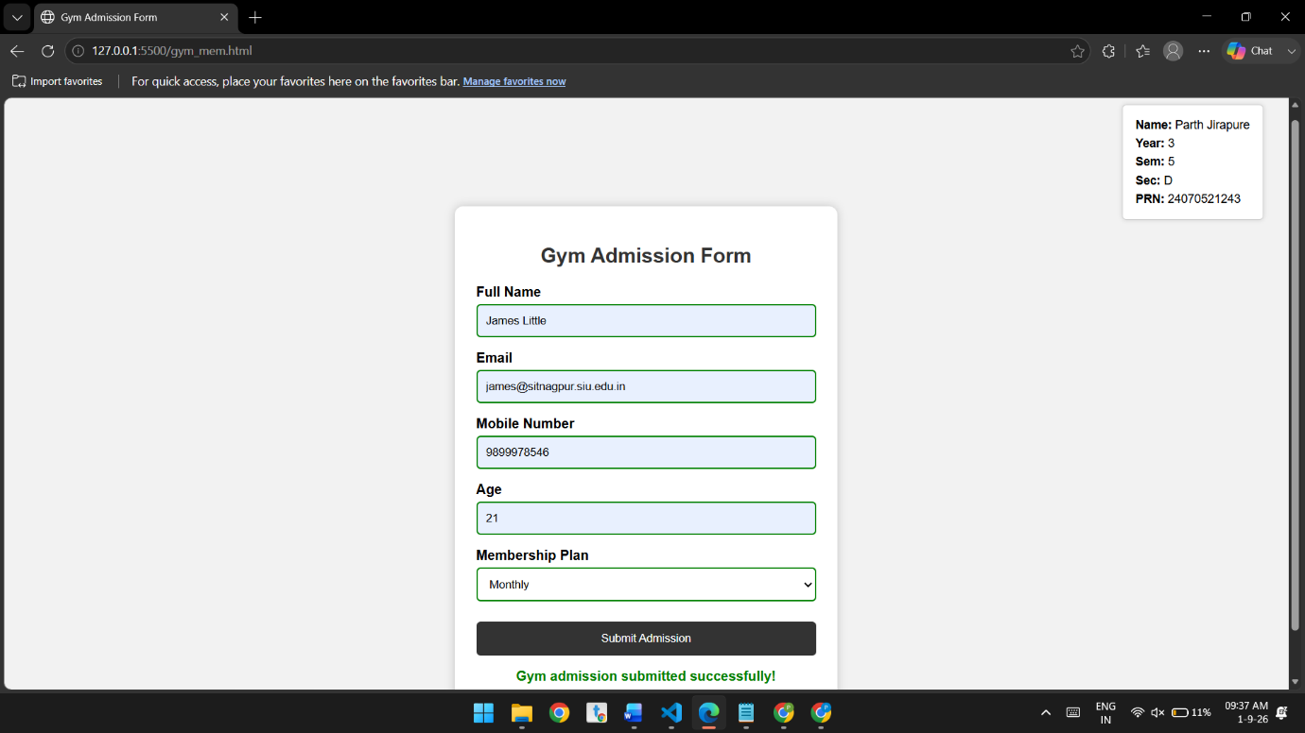
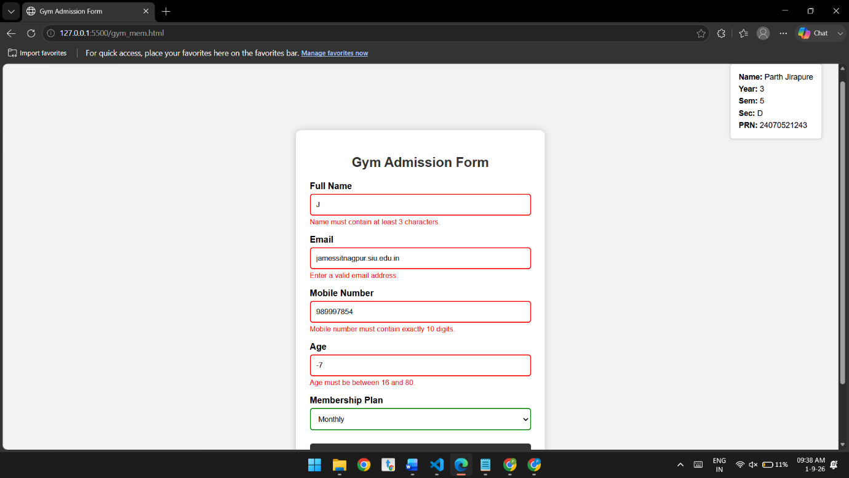

Conclusion:-
The gym admission form was successfully implemented with event-based live validation. It provides immediate feedback for invalid inputs and accepts the form only when all required details are valid.

Case Study – 8

Aim
To design and develop a Job Application Form using HTML and CSS and implement JavaScript-based form validation to ensure that the entered information is valid and all required fields are completed.

Software/Tools Required:-
- Visual Studio Code (or any text editor)
- Web Browser (Google Chrome/Microsoft Edge)
- HTML, CSS, and JavaScript

Code:-
<!DOCTYPE html>
<html lang="en">
<head>
<meta charset="UTF-8">
<meta name="viewport" content="width=device-width, initial-scale=1.0">
<title>Job Application Form</title>

<!-- Internal CSS -->
<style>
body {
font-family: Arial, sans-serif;
background-color: #f2f2f2;
margin: 0;
padding: 40px;
}

/* Student Details */
.student-details {
position: absolute;
top: 20px;
right: 30px;
background-color: white;
padding: 10px 15px;
border: 1px solid #ccc;
border-radius: 5px;
box-shadow: 0 0 5px rgba(0, 0, 0, 0.15);
font-size: 14px;
}

.student-details p {
margin: 5px 0;
}

/* Main Form */
.container {
width: 600px;
margin: 100px auto 0;
background-color: white;
padding: 25px;
border-radius: 10px;
box-shadow: 0 0 10px rgba(0, 0, 0, 0.2);
}

h2 {
text-align: center;
color: #333;
}

/* Section headings */
h3 {
color: #333;
margin-top: 25px;
border-bottom: 1px solid #ccc;
padding-bottom: 5px;
}

label {
display: block;
margin-top: 12px;
font-weight: bold;
}

input,
select,
textarea {
width: 100%;
padding: 9px;
margin-top: 5px;
box-sizing: border-box;
border: 1px solid #aaa;
border-radius: 5px;
}

textarea {
height: 70px;
resize: vertical;
}

input.valid,
select.valid,
textarea.valid {
border: 2px solid green;
}

input.invalid,
select.invalid,
textarea.invalid {
border: 2px solid red;
}

.error {
color: red;
font-size: 13px;
margin-top: 3px;
}

button {
width: 100%;
margin-top: 25px;
padding: 12px;
background-color: #333;
color: white;
border: none;
border-radius: 5px;
cursor: pointer;
font-size: 16px;
}

button:hover {
background-color: #555;
}

#success {
color: green;
text-align: center;
font-weight: bold;
margin-top: 15px;
}
</style>
</head>

<body>

<!-- Student Details at Top Right -->
<div class="student-details">
<p><strong>Name:</strong> Parth Jirapure</p>
<p><strong>Year:</strong> 3</p>
<p><strong>Sem:</strong> 5</p>
<p><strong>Sec:</strong> D</p>
<p><strong>PRN:</strong> 24070521243</p>
</div>

<!-- Main Form -->
<div class="container">

<h2>Job Application Form</h2>

<form id="applicationForm">

<!-- Personal Information -->
<h3>Personal Information</h3>

<label for="fullName">Full Name</label>
<input type="text" id="fullName"
placeholder="Enter your full name">
<div id="nameError" class="error"></div>

<label for="dob">Date of Birth</label>
<input type="date" id="dob">
<div id="dobError" class="error"></div>

<label for="gender">Gender</label>
<select id="gender">
<option value="">-- Select Gender --</option>
<option value="Male">Male</option>
<option value="Female">Female</option>
<option value="Other">Other</option>
</select>
<div id="genderError" class="error"></div>

<label for="email">Email Address</label>
<input type="email" id="email"
placeholder="Enter your email">
<div id="emailError" class="error"></div>

<label for="mobile">Mobile Number</label>
<input type="text" id="mobile"
placeholder="Enter 10-digit mobile number">
<div id="mobileError" class="error"></div>

<label for="address">Address</label>
<textarea id="address"
placeholder="Enter your address"></textarea>
<div id="addressError" class="error"></div>

<label for="city">City / State / PIN Code</label>
<input type="text" id="city"
placeholder="Enter City / State / PIN Code">
<div id="cityError" class="error"></div>

<!-- Educational Qualification -->
<h3>Educational Qualification</h3>

<label for="qualification">Highest Qualification</label>
<input type="text" id="qualification"
placeholder="Enter highest qualification">
<div id="qualificationError" class="error"></div>

<label for="university">University / Institute</label>
<input type="text" id="university"
placeholder="Enter university or institute">
<div id="universityError" class="error"></div>

<label for="passingYear">Passing Year</label>
<input type="number" id="passingYear"
placeholder="Enter passing year">
<div id="yearError" class="error"></div>

<label for="percentage">Percentage / CGPA</label>
<input type="text" id="percentage"
placeholder="Enter percentage or CGPA">
<div id="percentageError" class="error"></div>

<!-- Professional Information -->
<h3>Professional Information</h3>

<label for="jobPosition">Applying For / Job Position</label>
<input type="text" id="jobPosition"
placeholder="Enter job position">
<div id="jobError" class="error"></div>

<label for="experience">Total Work Experience</label>
<input type="text" id="experience"
placeholder="Example: 2 Years">
<div id="experienceError" class="error"></div>

<label for="organization">Current/Previous Organization</label>
<input type="text" id="organization"
placeholder="Enter organization name">
<div id="organizationError" class="error"></div>

<label for="designation">Current Designation</label>
<input type="text" id="designation"
placeholder="Enter current designation">
<div id="designationError" class="error"></div>

<label for="salary">Expected Salary</label>
<input type="text" id="salary"
placeholder="Enter expected salary">
<div id="salaryError" class="error"></div>

<!-- Technical Skills -->
<h3>Technical Skills</h3>

<label for="programming">Programming Languages</label>
<input type="text" id="programming"
placeholder="Example: C, C++, Java, Python">
<div id="programmingError" class="error"></div>

<label for="skills">Technical Skills</label>
<textarea id="skills"
placeholder="Enter your technical skills"></textarea>
<div id="skillsError" class="error"></div>

<label for="certifications">Certifications</label>
<textarea id="certifications"
placeholder="Enter your certifications"></textarea>
<div id="certificationError" class="error"></div>

<button type="submit">Submit Application</button>

<div id="success"></div>

</form>
</div>

<!-- Internal JavaScript -->
<script>

// Access form fields
const form = document.getElementById("applicationForm");

const fullName = document.getElementById("fullName");
const dob = document.getElementById("dob");
const gender = document.getElementById("gender");
const email = document.getElementById("email");
const mobile = document.getElementById("mobile");
const address = document.getElementById("address");
const city = document.getElementById("city");

const qualification =
document.getElementById("qualification");

const university =
document.getElementById("university");

const passingYear =
document.getElementById("passingYear");

const percentage =
document.getElementById("percentage");

const jobPosition =
document.getElementById("jobPosition");

const experience =
document.getElementById("experience");

const organization =
document.getElementById("organization");

const designation =
document.getElementById("designation");

const salary =
document.getElementById("salary");

const programming =
document.getElementById("programming");

const skills =
document.getElementById("skills");

const certifications =
document.getElementById("certifications");

// Function for text validation
function validateText(field, errorId, message) {

const error = document.getElementById(errorId);

if (field.value.trim().length < 2) {

error.textContent = message;

field.classList.add("invalid");
field.classList.remove("valid");

return false;

} else {

error.textContent = "";

field.classList.add("valid");
field.classList.remove("invalid");

return true;
}
}

// Full Name - input event
fullName.addEventListener("input", function () {

validateText(
fullName,
"nameError",
"Please enter your full name."
);

});

// Email - input event
email.addEventListener("input", function () {

const error =
document.getElementById("emailError");

const emailPattern =
/^[^ ]+@[^ ]+\.[a-z]{2,3}$/;

if (!emailPattern.test(email.value.trim())) {

error.textContent =
"Please enter a valid email address.";

email.classList.add("invalid");
email.classList.remove("valid");

} else {

error.textContent = "";

email.classList.add("valid");
email.classList.remove("invalid");
}

});

// Mobile - input event
mobile.addEventListener("input", function () {

const error =
document.getElementById("mobileError");

const mobilePattern = /^[0-9]{10}$/;

if (!mobilePattern.test(mobile.value)) {

error.textContent =
"Mobile number must contain 10 digits.";

mobile.classList.add("invalid");
mobile.classList.remove("valid");

} else {

error.textContent = "";

mobile.classList.add("valid");
mobile.classList.remove("invalid");
}

});

// Date of Birth - change event
dob.addEventListener("change", function () {

const error =
document.getElementById("dobError");

if (dob.value === "") {

error.textContent =
"Please select your date of birth.";

dob.classList.add("invalid");

} else {

error.textContent = "";

dob.classList.add("valid");
dob.classList.remove("invalid");
}

});

// Gender - change event
gender.addEventListener("change", function () {

const error =
document.getElementById("genderError");

if (gender.value === "") {

error.textContent =
"Please select your gender.";

gender.classList.add("invalid");

} else {

error.textContent = "";

gender.classList.add("valid");
gender.classList.remove("invalid");
}

});

// Address - input event
address.addEventListener("input", function () {

validateText(
address,
"addressError",
"Please enter your address."
);

});

// City / State / PIN - input event
city.addEventListener("input", function () {

validateText(
city,
"cityError",
"Please enter City / State / PIN Code."
);

});

// Educational fields
qualification.addEventListener("input", function () {

validateText(
qualification,
"qualificationError",
"Please enter your qualification."
);

});

university.addEventListener("input", function () {

validateText(
university,
"universityError",
"Please enter university/institute."
);

});

passingYear.addEventListener("input", function () {

const error =
document.getElementById("yearError");

const year = Number(passingYear.value);

if (year < 1950 || year > 2100) {

error.textContent =
"Enter a valid passing year.";

passingYear.classList.add("invalid");
passingYear.classList.remove("valid");

} else {

error.textContent = "";

passingYear.classList.add("valid");
passingYear.classList.remove("invalid");
}

});

percentage.addEventListener("input", function () {

validateText(
percentage,
"percentageError",
"Please enter Percentage / CGPA."
);

});

// Professional Information
jobPosition.addEventListener("input", function () {

validateText(
jobPosition,
"jobError",
"Please enter the job position."
);

});

experience.addEventListener("input", function () {

validateText(
experience,
"experienceError",
"Please enter work experience."
);

});

organization.addEventListener("input", function () {

validateText(
organization,
"organizationError",
"Please enter organization name."
);

});

designation.addEventListener("input", function () {

validateText(
designation,
"designationError",
"Please enter designation."
);

});

salary.addEventListener("input", function () {

validateText(
salary,
"salaryError",
"Please enter expected salary."
);

});

// Technical Skills
programming.addEventListener("input", function () {

validateText(
programming,
"programmingError",
"Please enter programming languages."
);

});

skills.addEventListener("input", function () {

validateText(
skills,
"skillsError",
"Please enter technical skills."
);

});

certifications.addEventListener("input", function () {

validateText(
certifications,
"certificationError",
"Please enter certifications."
);

});

// Submit event
form.addEventListener("submit", function (event) {

event.preventDefault();

let valid = true;

// Check required fields
const fields = [
fullName,
dob,
gender,
email,
mobile,
address,
city,
qualification,
university,
passingYear,
percentage,
jobPosition,
experience,
organization,
designation,
salary,
programming,
skills,
certifications
];

fields.forEach(function (field) {

if (field.value.trim() === "") {
valid = false;
field.classList.add("invalid");
}

});

if (valid) {

document.getElementById("success").textContent =
"Application submitted successfully!";

} else {

document.getElementById("success").textContent =
"Please fill in all required fields correctly.";

}

});

</script>

</body>
</html>

Theory
HTML is used to create the structure of the Job Application Form, including fields for personal information, educational qualifications, professional information, and technical skills. CSS is used for styling the form, such as layout, colors, borders, spacing, and validation indicators.
JavaScript is used to provide client-side form validation. Different validation rules are applied to the input fields. For example, text fields must contain at least two characters, the email must follow a valid email pattern, the mobile number must contain exactly 10 digits, and the passing year must be between 1950 and 2100.
The form also provides visual feedback by displaying green borders for valid fields and red borders for invalid fields, along with appropriate error messages. On submission, JavaScript checks whether all required fields are correctly filled and displays either a successful submission message or an error message.

Output:-
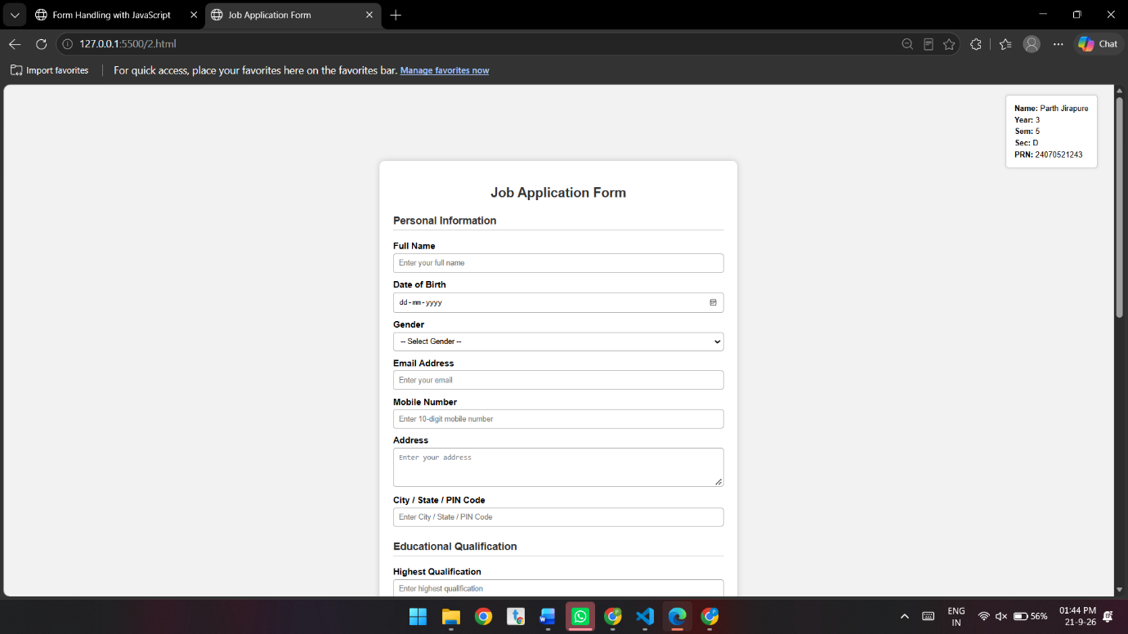
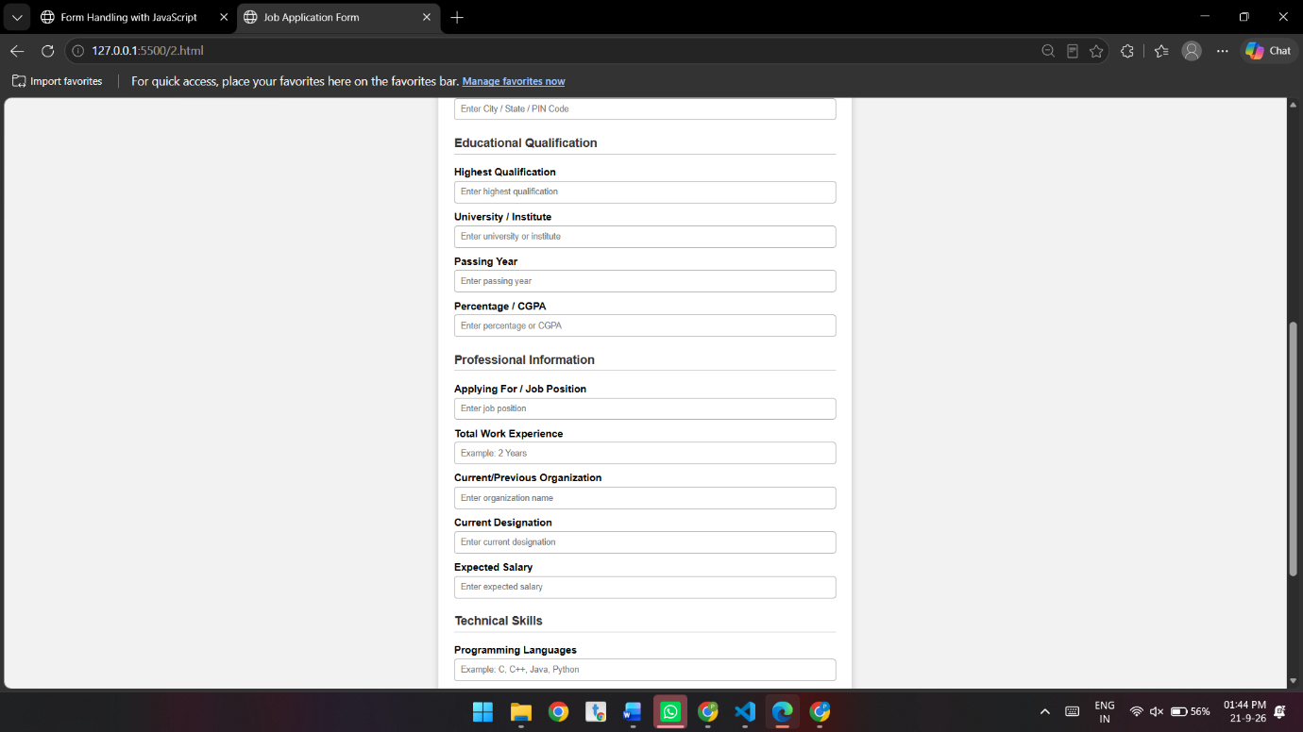
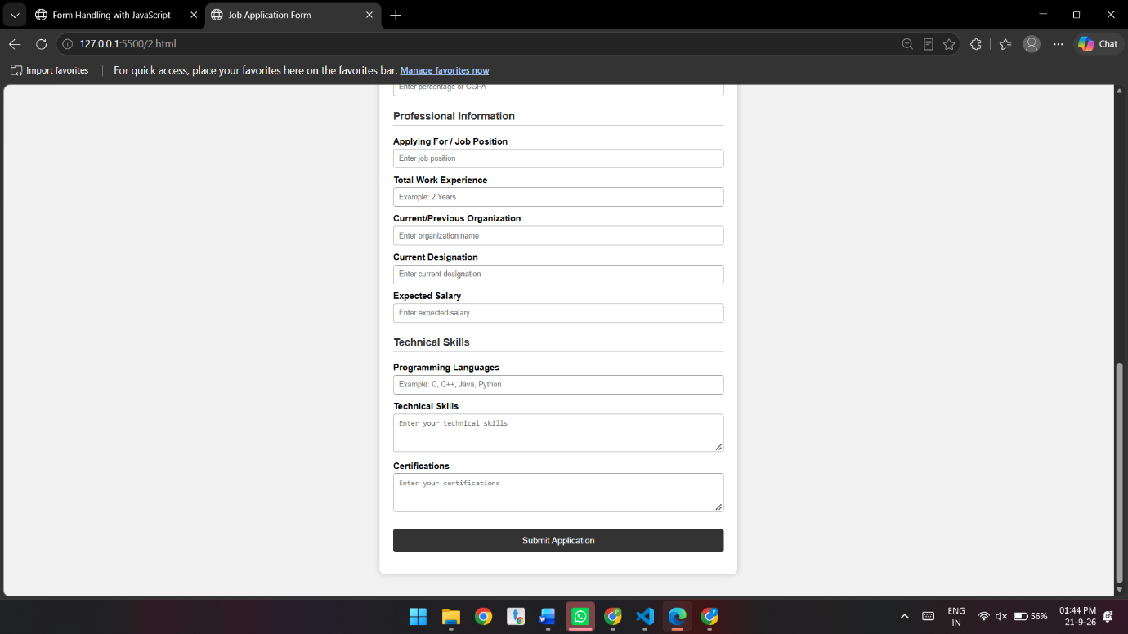

Conclusion
The Job Application Form was successfully designed and implemented using HTML, CSS, and JavaScript. The form accepts personal, educational, professional, and technical information and performs client-side validation to identify incorrect or missing inputs. Thus, the experiment demonstrates the use of HTML for structure, CSS for presentation, and JavaScript for interactive form validation.

Experiment – 9

Aim:-
Implement localStorage and sessionStorage to save user preferences like theme settings.

Software/Tools Required:-
- Visual Studio Code (or any text editor)
- Web Browser (Google Chrome/Microsoft Edge)
- HTML, CSS, and JavaScript

Code:-
<!DOCTYPE html>
<html lang="en">
<head>
<meta charset="UTF-8">
<meta name="viewport" content="width=device-width, initial-scale=1.0">

<title>Theme Settings</title>

<style>
* {
box-sizing: border-box;
}

body {
margin: 0;
min-height: 100vh;
font-family: Arial, Helvetica, sans-serif;

display: flex;
align-items: center;
justify-content: center;

background-color: #f2f2f2;
color: #222;

transition: 0.3s;
}

/* Student Details Box */
.student-info {
position: absolute;
top: 20px;
right: 20px;

padding: 15px 20px;

background-color: white;
color: #222;

border: 1px solid #222;
border-radius: 5px;

box-shadow: 0 2px 8px rgba(0, 0, 0, 0.15);

text-align: left;
font-size: 14px;
}

.student-info p {
margin: 6px 0;
}

/* Main Theme Settings Box */
.container {
width: 600px;
padding: 40px;

text-align: center;

background-color: white;
border: 1px solid #222;
border-radius: 3px;

box-shadow: 0 2px 8px rgba(0, 0, 0, 0.08);

transition: 0.3s;
}

h1 {
margin-top: 0;
margin-bottom: 25px;
font-size: 30px;
}

.description {
font-size: 16px;
margin-bottom: 20px;
}

select {
padding: 8px 12px;
font-size: 15px;
cursor: pointer;

border: 1px solid #aaa;
border-radius: 4px;
background-color: white;
}

/* Buttons */
.buttons {
margin-top: 25px;

display: flex;
justify-content: center;
gap: 15px;

flex-wrap: wrap;
}

button {
padding: 10px 15px;

border: 1px solid #aaa;
border-radius: 4px;

background-color: #e9e9e9;
color: #222;

cursor: pointer;
font-size: 14px;
}

button:hover {
background-color: #d5d5d5;
}

.clear-button {
margin-top: 20px;
}

#message {
min-height: 22px;
margin-top: 25px;

font-size: 15px;
font-weight: bold;
}

/* =========================
DARK THEME
========================= */

body.dark {
background-color: #191919;
color: white;
}

body.dark .container {
background-color: #292929;
border-color: #555;
}

body.dark .student-info {
background-color: #292929;
color: white;
border-color: #555;
}

body.dark select,
body.dark button {
background-color: #eeeeee;
color: #111;
}
</style>
</head>

<body>

<!-- =========================
STUDENT DETAILS
Outside the main form
========================= -->

<div class="student-info">

<p>
<strong>Name:</strong>
Parth Jirapure
</p>

<p>
<strong>Year:</strong>
3
</p>

<p>
<strong>Sem:</strong>
5
</p>

<p>
<strong>PRN:</strong>
24070521243
</p>

</div>

<!-- =========================
THEME SETTINGS
========================= -->

<div class="container">

<h1>Theme Settings</h1>

<p class="description">
Select your preferred theme:
</p>

<!-- Theme Selection -->

<select id="themeSelect">

<option value="light">
Light
</option>

<option value="dark">
Dark
</option>

</select>

<!-- Storage Buttons -->

<div class="buttons">

<button onclick="saveLocalStorage()">
Save using localStorage
</button>

<button onclick="saveSessionStorage()">
Save using sessionStorage
</button>

</div>

<!-- Clear Preferences -->

<button
class="clear-button"
onclick="clearPreferences()">

Clear Preferences

</button>

<!-- Status Message -->

<p id="message"></p>

</div>

<!-- =========================
JAVASCRIPT
========================= -->

<script>

// Get HTML elements
const themeSelect =
document.getElementById("themeSelect");

const message =
document.getElementById("message");

// --------------------------------
// Apply selected theme
// --------------------------------

function applyTheme(theme) {

if (theme === "dark") {

document.body.classList.add("dark");

} else {

document.body.classList.remove("dark");

}

themeSelect.value = theme;
}

// --------------------------------
// Save using localStorage
// --------------------------------

function saveLocalStorage() {

const theme =
themeSelect.value;

// Store theme permanently
localStorage.setItem(
"theme",
theme
);

// Remove session storage
sessionStorage.removeItem("theme");

// Apply theme
applyTheme(theme);

// Display message
message.textContent =
"Theme saved using localStorage.";
}

// --------------------------------
// Save using sessionStorage
// --------------------------------

function saveSessionStorage() {

const theme =
themeSelect.value;

// Store theme for current session
sessionStorage.setItem(
"theme",
theme
);

// Remove local storage
localStorage.removeItem("theme");

// Apply theme
applyTheme(theme);

// Display message
message.textContent =
"Theme saved using sessionStorage.";
}

// --------------------------------
// Clear Preferences
// --------------------------------

function clearPreferences() {

// Remove localStorage
localStorage.removeItem("theme");

// Remove sessionStorage
sessionStorage.removeItem("theme");

// Reset to light theme
applyTheme("light");

// Display message
message.textContent =
"Preferences cleared.";
}

// --------------------------------
// Load saved theme
// --------------------------------

function loadTheme() {

// Check localStorage
const localTheme =
localStorage.getItem("theme");

// Check sessionStorage
const sessionTheme =
sessionStorage.getItem("theme");

if (localTheme) {

// Load localStorage theme
applyTheme(localTheme);

message.textContent =
"Theme loaded from localStorage.";

}

else if (sessionTheme) {

// Load sessionStorage theme
applyTheme(sessionTheme);

message.textContent =
"Theme loaded from sessionStorage.";

}

else {

// Default theme
applyTheme("light");

}
}

// --------------------------------
// Change theme immediately
// --------------------------------

themeSelect.addEventListener(
"change",
function () {

const theme =
themeSelect.value;

applyTheme(theme);

message.textContent =
"Theme changed. Select a storage option to save it.";

}
);

// --------------------------------
// Load theme when page starts
// --------------------------------

loadTheme();

</script>

</body>
</html>

Theory:-
The Web Storage API provides a simple way to store data in a user's web browser using key-value pairs. It allows JavaScript to save information on the client side without requiring a server or database. The two main storage mechanisms provided by the browser are localStorage and sessionStorage.
In this experiment, localStorage and sessionStorage are used to implement a Theme Settings page that allows the user to select and save a preferred Light or Dark theme. JavaScript is used to access the selected theme and store the preference in the browser's storage.
The localStorage mechanism is used when the user wants the selected theme to remain saved even after closing or reopening the webpage. The selected theme is stored using methods such as setItem() and can later be retrieved using getItem(). This makes localStorage suitable for storing permanent user preferences such as theme, language, or display settings.
The sessionStorage mechanism is used to store the selected theme temporarily during the current browser session. The preference remains available while the session is active but is removed when the browser tab or session is closed. This makes sessionStorage useful for temporary user settings that do not need to be remembered permanently.
The experiment also provides a Clear Preferences option to remove the stored theme settings. JavaScript uses methods such as removeItem() or clear() to delete the stored information. A status message is displayed on the page to indicate whether the theme was saved using localStorage, sessionStorage, or whether the preferences were cleared.
This experiment demonstrates how browser storage, JavaScript, and DOM manipulation can work together to maintain user preferences. It provides practical understanding of how data can be stored, retrieved, and removed on the client side, and how persistent and temporary storage differ in web applications.

Output:-
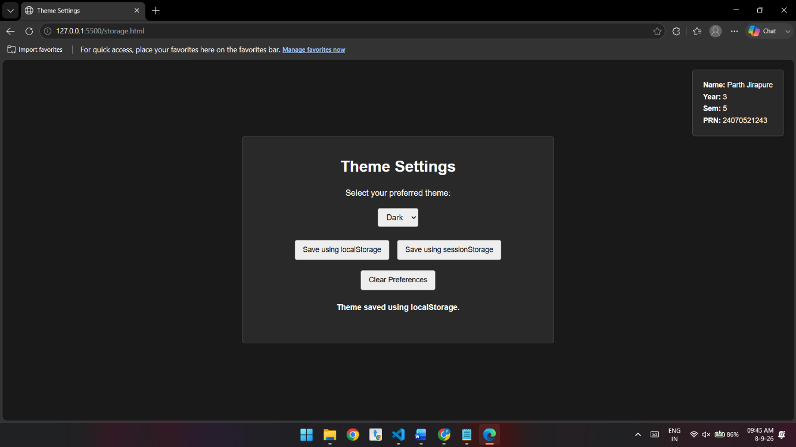
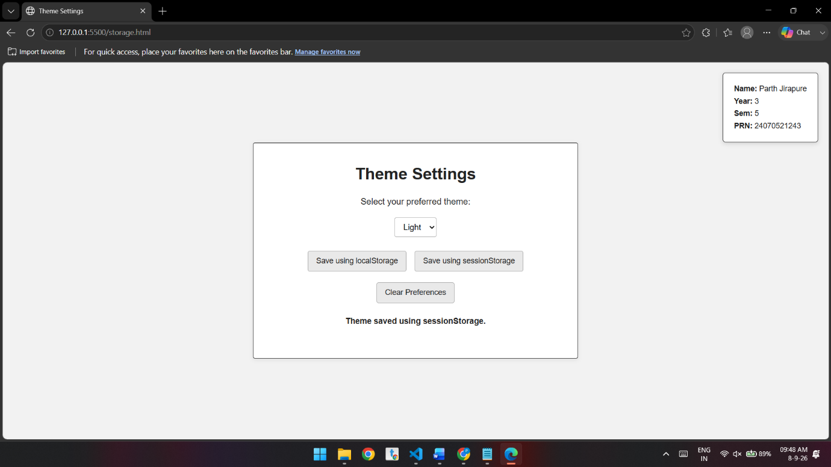

Conclusion:-
The experiment successfully demonstrates the use of localStorage and sessionStorage for storing user preferences such as theme settings. localStorage provides persistent storage, allowing preferences to remain available across browser sessions, whereas sessionStorage provides temporary storage for the current session.
Case Study – 9

Aim:
To implement and integrate the concepts studied from Experiment 1 to Experiment 8 to develop an interactive web page with Light and Dark Theme background switching using HTML, CSS, and JavaScript.

Software/Tools Required:-
- Visual Studio Code (or any text editor)
- Web Browser (Google Chrome/Microsoft Edge)
- HTML, CSS, and JavaScript

Theory
A web page can provide different visual themes using CSS and JavaScript. In the light theme, the page uses a light background with dark text, while in the dark theme, the background and content areas are changed to dark colors with white text.
JavaScript is used to dynamically change the theme. The toggleTheme() function adds or removes the dark-mode class from the <body> element using classList.toggle(). When dark mode is active, the button text changes to " Light Mode", and when light mode is active, it changes back to "Dark Mode".
CSS transitions are also used to make the theme change smoother. The experiment demonstrates how CSS provides the appearance of the themes while JavaScript provides interactive theme switching.

Output:-
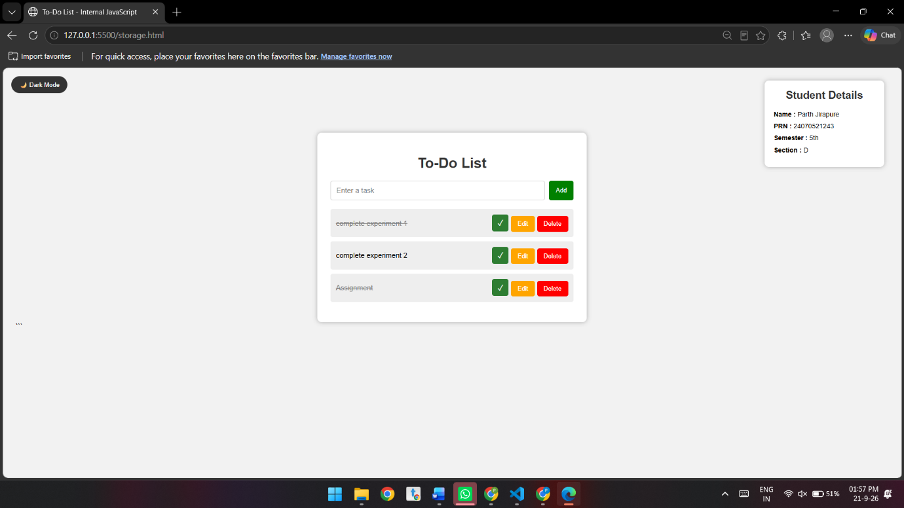
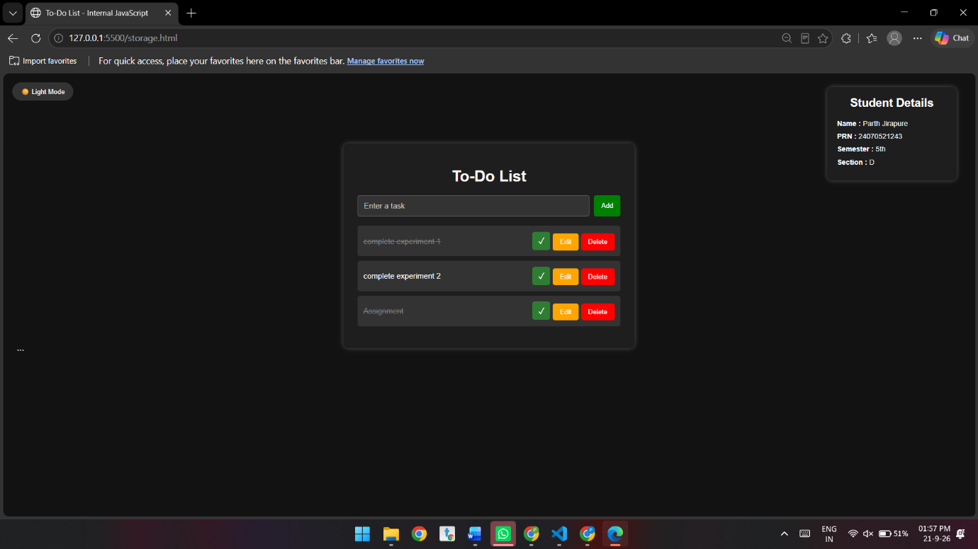

Conclusion
The Light and Dark Theme was successfully implemented using HTML, CSS, and JavaScript. The webpage switches between themes using a button, demonstrating CSS styling and JavaScript theme switching.

Experiment – 10

Aim:-
Load and display JSON data using fetch() and jQuery $.getJSON(); render results dynamically in a table.

Software/Tools Required:-
- Visual Studio Code (or any text editor)
- Web Browser (Google Chrome/Microsoft Edge)
- HTML, CSS, and JavaScript

Code:-
<!DOCTYPE html>
<html lang="en">

<head>
<meta charset="UTF-8">

<meta name="viewport"
content="width=device-width, initial-scale=1.0">

<title>JSON Data Loading</title>

<!-- jQuery Library -->
<script src="https://code.jquery.com/jquery-3.7.1.min.js"></script>

<style>

/* ==============================
BODY
============================== */

body {
font-family: Arial, sans-serif;
background-color: white;
color: black;
text-align: center;
margin: 0;
padding-top: 40px;
}

/* ==============================
STUDENT DETAILS
TOP RIGHT
============================== */

.student-details {

position: absolute;

top: 10px;
right: 15px;

background-color: white;
color: black;

border: 3px solid black;

padding: 10px 15px;

text-align: left;

font-size: 14px;
}

.student-details h3 {

margin: 0 0 8px 0;

color: black;

text-align: center;
}

.student-details p {

margin: 4px 0;

color: black;
}

/* ==============================
MAIN HEADING
============================== */

h1 {
color: black;
}

/* ==============================
BUTTONS
============================== */

button {

padding: 10px 20px;

margin: 10px;

background-color: white;

color: black;

border: 2px solid black;

cursor: pointer;
}

button:hover {

background-color: black;

color: white;
}

/* ==============================
TABLE
============================== */

table {

width: 70%;

margin: 20px auto;

border-collapse: collapse;

background-color: white;

color: black;
}

th,
td {

border: 2px solid black;

padding: 10px;
}

th {

background-color: black;

color: white;
}

td {

background-color: white;

color: black;
}

</style>

</head>

<body>

<!-- ==================================
STUDENT DETAILS
================================== -->

<div class="student-details">

<h3>Student Details</h3>

<p>
<b>Name:</b> Parth Jirapure
</p>

<p>
<b>Year:</b> 3
</p>

<p>
<b>Sem:</b> 5
</p>

<p>
<b>PRN:</b> 24070521243
</p>

</div>

<!-- ==================================
MAIN CONTENT
================================== -->

<h1>Student Details</h1>

<!-- ==================================
BUTTONS
================================== -->

<button onclick="loadFetch()">
Load using fetch()
</button>

<button onclick="loadJQuery()">
Load using $.getJSON()
</button>

<!-- ==================================
TABLE
================================== -->

<table>

<thead>

<tr>

<th>ID</th>

<th>Name</th>

<th>Email</th>

</tr>

</thead>

<tbody id="studentTable">

<!-- JSON data will be displayed here -->

</tbody>

</table>

<!-- ==================================
JAVASCRIPT
================================== -->

<script>

// ==================================
// JSON DATA
// ==================================

const students = [

{
"id": 1,
"name": "Ram",
"email": "ram23@gmail.com"
},

{
"id": 2,
"name": "Priya",
"email": "priya31@gmail.com"
},

{
"id": 3,
"name": "Amit",
"email": "amit12@gmail.com"
},

{
"id": 4,
"name": "Karan",
"email": "karan06@gmail.com"
}

];

// ==================================
// CONVERT JSON INTO BLOB
// ==================================

const jsonBlob = new Blob(

[
JSON.stringify(students)
],

{
type: "application/json"
}

);

// ==================================
// CREATE JSON URL
// ==================================

const jsonURL =
URL.createObjectURL(jsonBlob);

// ==================================
// USING fetch()
// ==================================

function loadFetch() {

fetch(jsonURL)

.then(function(response) {

// Convert response into JSON

return response.json();

})

.then(function(data) {

// Get table body

let table =
document.getElementById(
"studentTable"
);

// Clear old data

table.innerHTML = "";

// Loop through JSON data

data.forEach(
function(student) {

// Create table row

let row = `

<tr>

<td>
${student.id}
</td>

<td>
${student.name}
</td>

<td>
${student.email}
</td>

</tr>

`;

// Add row to table

table.innerHTML += row;

}
);

})

.catch(function(error) {

console.log(
"Error loading JSON:",
error
);

});

}

// ==================================
// USING jQuery $.getJSON()
// ==================================

function loadJQuery() {

$.getJSON(

jsonURL,

function(data) {

// Clear old data

$("#studentTable").html("");

// Loop through JSON data

$.each(

data,

function(index, student) {

// Create table row

let row = `

<tr>

<td>
${student.id}
</td>

<td>
${student.name}
</td>

<td>
${student.email}
</td>

</tr>

`;

// Add row to table

$("#studentTable").append(row);

}

);

}

)

// Error handling

.fail(function() {

console.log(
"Error loading JSON"
);

});

}

</script>

</body>

</html>

Theory:-
The JSON (JavaScript Object Notation) is a lightweight and widely used data-interchange format for storing and transferring structured data. It represents information in the form of key-value pairs and arrays, making it easy for both humans and web applications to read and process. JSON is commonly used in web applications to exchange data between a client and a server.
In this experiment, JSON data is loaded and displayed dynamically in an HTML table using two different methods: the JavaScript fetch() API and the jQuery $.getJSON() method. The webpage contains buttons that allow the user to load student details such as ID, Name, and Email from a JSON file.
The fetch() API is a modern JavaScript feature used to make HTTP requests and retrieve resources such as JSON files. It returns a Promise that can be handled using .then() and .catch(). The response.json() method is used to convert the received JSON data into a JavaScript object or array. The data can then be processed using JavaScript and dynamically inserted into the HTML table.
The jQuery $.getJSON() method provides a simple way to retrieve JSON data from a specified file or URL using an HTTP GET request. It automatically parses the JSON response and passes the resulting data to a callback function. The retrieved student information can then be used to create table rows and display the data on the webpage.
The experiment also demonstrates DOM manipulation, where JavaScript is used to create or update HTML elements dynamically based on the retrieved JSON data. Instead of writing every student record directly in the HTML code, the records are generated from the JSON file at runtime. This makes the webpage more flexible and easier to update, because apparently humans eventually discovered that copying four rows of data by hand is not a sustainable software architecture.

Output:-
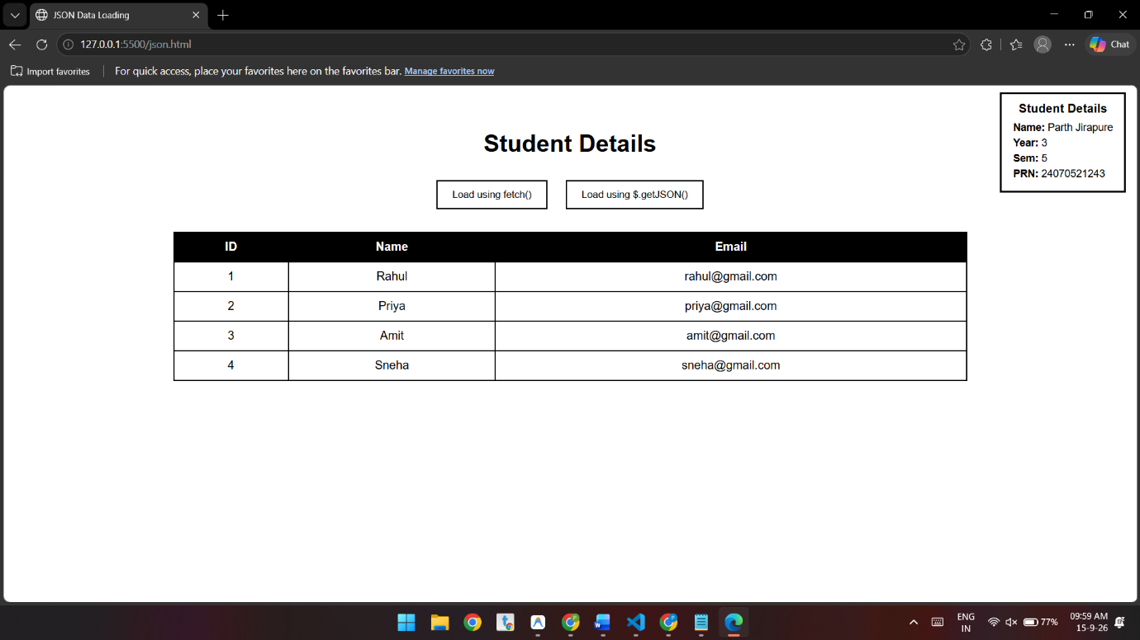

Conclusion:-
This experiment demonstrates how JSON, fetch(), $.getJSON(), and DOM manipulation are used to retrieve and dynamically display data in an HTML table. It provides practical understanding of JSON parsing and asynchronous data retrieval.

Case study – 10

Aim
To develop a Campus Event Registration System using HTML, CSS, JavaScript, JSON, Fetch API, and jQuery to load, display, search, and filter student registration data.

Software/Tools Required:-
- Visual Studio Code (or any text editor)
- Web Browser (Google Chrome/Microsoft Edge)
- HTML, CSS, and JavaScript

Code:-
<!DOCTYPE html>
<html lang="en">

<head>

<meta charset="UTF-8">

<meta name="viewport"
content="width=device-width, initial-scale=1.0">

<title>Campus Event Registration System</title>

<!-- jQuery CDN -->
<script src="https://code.jquery.com/jquery-3.7.1.min.js"></script>

<style>

* {
box-sizing: border-box;
}

body {
font-family: Arial, sans-serif;
background-color: #f2f2f2;
margin: 0;
padding: 20px;
}

.container {
max-width: 1200px;
margin: auto;
background-color: white;
padding: 25px;
border-radius: 10px;
box-shadow: 0 0 10px gray;
}

h1 {
text-align: center;
color: #234b7a;
margin-bottom: 25px;
}

.controls {
display: flex;
gap: 10px;
flex-wrap: wrap;
margin-bottom: 20px;
}

button,
input,
select {
padding: 12px;
font-size: 15px;
border-radius: 5px;
border: 1px solid #aaa;
}

button {
background-color: #234b7a;
color: white;
border: none;
cursor: pointer;
}

button:hover {
background-color: #16365a;
}

input {
flex: 1;
min-width: 200px;
}

select {
min-width: 200px;
}

#message {
display: none;
padding: 12px;
margin-bottom: 15px;
border-radius: 5px;
font-weight: bold;
}

.success {
background-color: #d4edda;
color: #155724;
}

.error {
background-color: #f8d7da;
color: #721c24;
}

.table-container {
overflow-x: auto;
}

table {
width: 100%;
border-collapse: collapse;
min-width: 900px;
}

th {
background-color: #234b7a;
color: white;
padding: 14px;
text-align: center;
}

td {
padding: 12px;
border: 1px solid #ddd;
text-align: center;
}

tr:nth-child(even) {
background-color: #f2f2f2;
}

tr:hover {
background-color: #eaf2ff;
}

.registered {
color: green;
font-weight: bold;
}

.pending {
color: orange;
font-weight: bold;
}

.cancelled {
color: red;
font-weight: bold;
}

.empty {
text-align: center;
padding: 20px;
color: #666;
}

@media (max-width: 600px) {

body {
padding: 10px;
}

.container {
padding: 15px;
}

h1 {
font-size: 24px;
}

.controls {
flex-direction: column;
}

button,
input,
select {
width: 100%;
}

}

</style>

</head>

<body>

<div class="container">

<h1>Campus Event Registration System</h1>

<div class="controls">

<!-- Fetch Button -->
<button id="fetchBtn">
Load Student Data (Fetch)
</button>

<!-- jQuery Button -->
<button id="jqueryBtn">
Load Student Data (jQuery)
</button>

<!-- Search Box -->
<input
type="text"
id="searchBox"
placeholder="Search by Student Name or PRN"
>

<!-- Registration Status Filter -->
<select id="statusFilter">

<option value="All">
All Registration Status
</option>

<option value="Registered">
Registered
</option>

<option value="Pending">
Pending
</option>

<option value="Cancelled">
Cancelled
</option>

</select>

</div>

<!-- Message Area -->
<div id="message"></div>

<!-- Student Table -->
<div class="table-container">

<table>

<thead>

<tr>

<th>Sr. No.</th>
<th>Student Name</th>
<th>PRN</th>
<th>Department</th>
<th>Year</th>
<th>Event Name</th>
<th>Registration Status</th>

</tr>

</thead>

<tbody id="studentTableBody">

<tr>

<td colspan="7" class="empty">

Click Load Student Data to display students.

</td>

</tr>

</tbody>

</table>

</div>

</div>

<!-- =========================================
INTERNAL JSON DATA
========================================= -->

<script id="studentData" type="application/json">

[
{
"studentName": "Parth Jirapure",
"prn": "1234567890",
"department": "Computer Engineering",
"year": "3rd Year",
"eventName": "Tech Fest",
"registrationStatus": "Registered"
},

{
"studentName": "Aarav Patil",
"prn": "1234567891",
"department": "Information Technology",
"year": "2nd Year",
"eventName": "Hackathon",
"registrationStatus": "Pending"
},

{
"studentName": "Sneha Sharma",
"prn": "1234567892",
"department": "Computer Engineering",
"year": "3rd Year",
"eventName": "Cultural Fest",
"registrationStatus": "Registered"
},

{
"studentName": "Rohan Deshmukh",
"prn": "1234567893",
"department": "Mechanical Engineering",
"year": "4th Year",
"eventName": "Sports Meet",
"registrationStatus": "Cancelled"
},

{
"studentName": "Priya Kulkarni",
"prn": "1234567894",
"department": "Electronics",
"year": "1st Year",
"eventName": "Tech Fest",
"registrationStatus": "Pending"
},

{
"studentName": "Neha Joshi",
"prn": "1234567895",
"department": "Civil Engineering",
"year": "2nd Year",
"eventName": "Tech Fest",
"registrationStatus": "Registered"
}

]

</script>

<!-- =========================================
JAVASCRIPT
========================================= -->

<script>

// Global student array
let students = [];

// Create a temporary JSON URL
function getJSONURL() {

let jsonText =
document.getElementById("studentData").textContent;

let blob = new Blob(
[jsonText],
{ type: "application/json" }
);

return URL.createObjectURL(blob);

}

// =========================================
// DISPLAY MESSAGE
// =========================================

function showMessage(message, type) {

let messageBox =
document.getElementById("message");

messageBox.textContent = message;

messageBox.className = type;

messageBox.style.display = "block";

}

// =========================================
// DISPLAY STUDENTS IN TABLE
// =========================================

function displayStudents(data) {

let tableBody =
document.getElementById("studentTableBody");

tableBody.innerHTML = "";

// No matching students
if (data.length === 0) {

tableBody.innerHTML = `

<tr>

<td colspan="7" class="empty">

No student matches the
search/filter criteria.

</td>

</tr>

`;

return;

}

// Create table rows dynamically
data.forEach(function(student, index) {

let row =
document.createElement("tr");

let statusClass =
student.registrationStatus.toLowerCase();

row.innerHTML = `

<td>${index + 1}</td>

<td>${student.studentName}</td>

<td>${student.prn}</td>

<td>${student.department}</td>

<td>${student.year}</td>

<td>${student.eventName}</td>

<td class="${statusClass}">

${student.registrationStatus}

</td>

`;

tableBody.appendChild(row);

});

}

// =========================================
// SEARCH AND FILTER FUNCTION
// =========================================

function filterStudents() {

let searchText =
document.getElementById("searchBox")
.value
.toLowerCase()
.trim();

let selectedStatus =
document.getElementById("statusFilter")
.value;

let filteredStudents =
students.filter(function(student) {

let matchesSearch =

student.studentName
.toLowerCase()
.includes(searchText)

||

String(student.prn)
.toLowerCase()
.includes(searchText);

let matchesStatus =

selectedStatus === "All"

||

student.registrationStatus
=== selectedStatus;

return matchesSearch && matchesStatus;

});

displayStudents(filteredStudents);

}

// =========================================
// METHOD 1: JAVASCRIPT FETCH()
// =========================================

function loadUsingFetch() {

let jsonURL = getJSONURL();

fetch(jsonURL)

.then(function(response) {

if (!response.ok) {

throw new Error(
"JSON data cannot be loaded."
);

}

return response.json();

})

.then(function(data) {

students = data;

displayStudents(students);

showMessage(
"Student data loaded successfully using fetch().",
"success"
);

URL.revokeObjectURL(jsonURL);

})

.catch(function(error) {

showMessage(
"Error: JSON data cannot be loaded.",
"error"
);

console.error(error);

URL.revokeObjectURL(jsonURL);

});

}

// =========================================
// METHOD 2: jQuery $.getJSON()
// =========================================

function loadUsingJQuery() {

let jsonURL = getJSONURL();

$.getJSON(jsonURL)

.done(function(data) {

students = data;

displayStudents(students);

showMessage(
"Student data loaded successfully using jQuery $.getJSON().",
"success"
);

URL.revokeObjectURL(jsonURL);

})

.fail(function(error) {

showMessage(
"Error: JSON data cannot be loaded using jQuery.",
"error"
);

console.error(error);

URL.revokeObjectURL(jsonURL);

});

}

// =========================================
// EVENT LISTENERS
// =========================================

document.getElementById("fetchBtn")
.addEventListener("click", loadUsingFetch);

document.getElementById("jqueryBtn")
.addEventListener("click", loadUsingJQuery);

document.getElementById("searchBox")
.addEventListener("input", filterStudents);

document.getElementById("statusFilter")
.addEventListener("change", filterStudents);

</script>

</body>

</html>
Theory:-
JSON (JavaScript Object Notation) is a lightweight format used to store and exchange structured data. In this experiment, student registration details such as name, PRN, department, year, event name, and registration status are stored in JSON format.
JavaScript is used to read the JSON data and dynamically display it in an HTML table. The Fetch API loads the JSON data using fetch(), while jQuery $.getJSON() provides an alternative method for loading the same data.
The system also uses JavaScript to implement search and filtering. Users can search students by name or PRN and filter records according to registration status such as Registered, Pending, or Cancelled. The table is updated dynamically based on the selected criteria.
Thus, the experiment demonstrates how JSON, JavaScript, Fetch API, jQuery, DOM manipulation, and event handling can be combined to create a dynamic campus event registration system.

Output:-
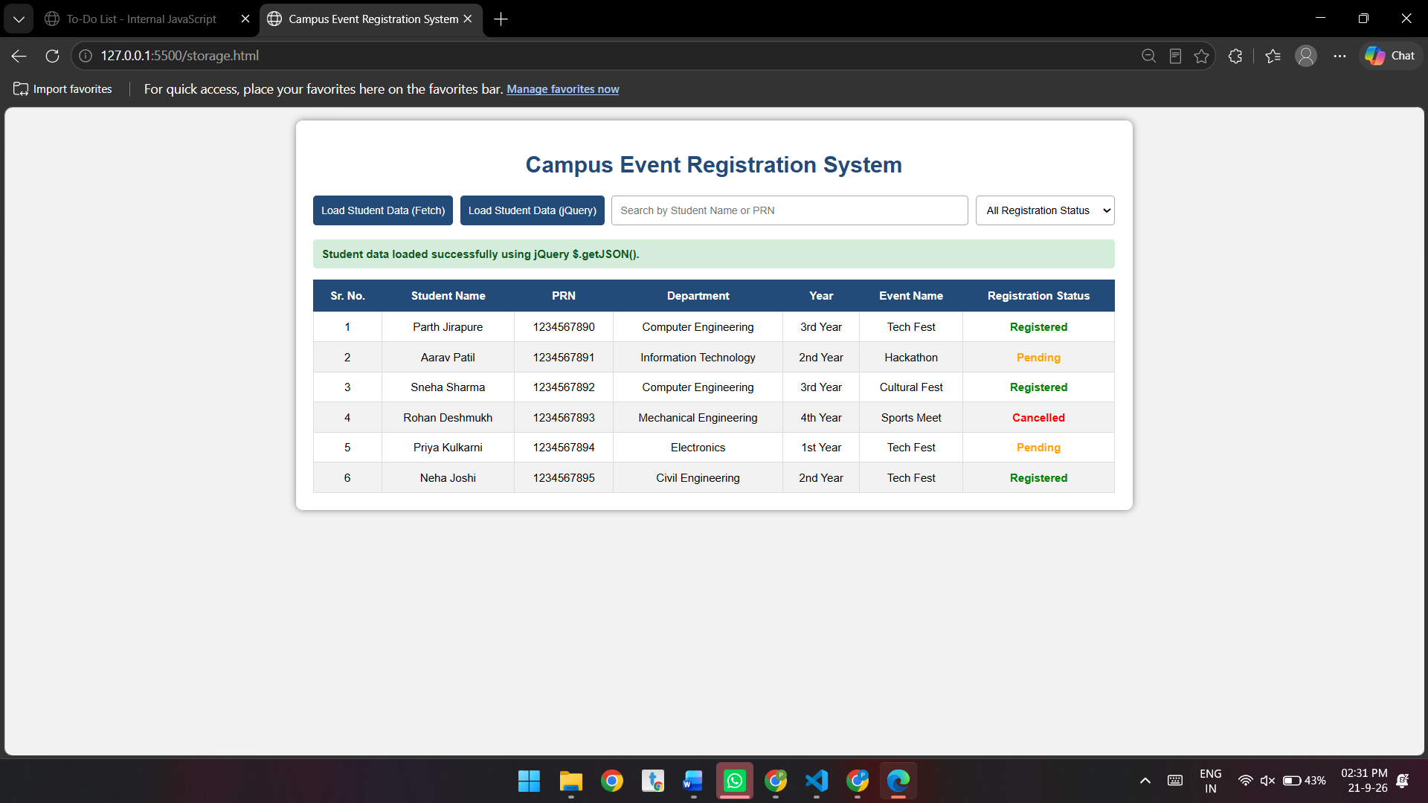

Conclusion
The Campus Event Registration System was successfully implemented using JSON, JavaScript Fetch API, and jQuery. Student data can be loaded, displayed, searched, and filtered efficiently.

